Telusko: Core Java 06

051 DOUBT
contact details
hyder: syedhyder@ineuron.ai
nitin : nitin@ineuron.ai
Retrieving Date value from the database
========================================
=> For this we can use either simple Statement or PreparedStatement.
=> The retrieved Date values are Stored in ResultSet in the form of "java.sql.Date"
and we can get this value by using getDate() method.
=> Once we got java.sql.Date object,we can format into our required form by using
SimpleDateFormat object.
Sequence
========
1. Database
(java.sql.Date)sqldate = rs.getDate(2);
2. Our required String Form
SimpleDateFormat sdf = new SimpleDateFormat("yyyy-mm-dd");
String s = sdf.format(sqldate);
3. String s holds the date.
System.out.println(s);
sir,can you explain this line Integer i=new Integer(1)+ new integer(2);
Integer i1 =new Integer(1);
Integer i2 = new Integer(2);
System.out.println(i1);//1
System.out.println(i2);//2
Integer i3 = i1+i2;
System.out.println(i3);//3
where we need to use \n \t and \r sir
\n => new line
\t =>horizontal tab space
\r => carriage return(taking the curson back to the same line at the begining)
Sir you have closed statement object but same way I have trying to close its show
me error? Why Sir?
import java.beans.Statement;//wrong import so error
import java.sql.Connection;
import java.sql.DriverManager;
import java.sql.ResultSet;
import java.sql.SQLException;
if(statement!=null)
statement.close();
It's showing me error.
Q>
What is the difference between: ` `, ' ', " "
`` => backticks(use when we specify column names of database)
'' => Single quote(use when we work with character)
"" => String(use when we work with String)
Q>
What is .length in array. its not a method, whats this actually?length => it is a property/fields of Array class.
class [I@...{
int length; //property of Array class which holds the size of an Array.
}
Q>
stmt-1;
try{
stmt-2;
stmt-3;//exception occured
stmt-4;
}catch(XXXX e){
stmt-5;
}finally{
stmt-6;
}
stmt-7;
stmt-1,2,5,6,7
Q>
Can throws keyword can be applied on methods only? or constructo too?
Answer: yes possible
Q>
Why have you put the constructor of JDBCutil as private? you said that you don't
want to create object of
that class? why that? and how that way? coz already you have put static in the
two methods: getConnection() and closeConnection()?
Answer: Cretion of an object is a costly event in realtime application,so avoid it.
To avoid object creation make constructor of a class a private.
make the class utility class, by writing the methods as static.
Q>
Why people are talk about java concurrency? I have obseving nowadays
Answer: Becoz the realtime applicatioin depends the usage of "MultiThreading".
Q>
How to run jdbc programs from command prompt?
set path and classpath environmental variables as shown below before running from
command prompt.
D:\Wrapper classes>echo %path%
C:\Program Files\Java\jdk1.8.0_202\bin;
D:\Wrapper classes>echo %classpath%
.;D:\jars\mysql-connector-j-8.0.31.jar;
Eg:
unicode values => fixed
eg: A => 65
B => 66
;;;
;;;
a => 97
b => 98;;;;;
;;;;
WHat is the diffrence between object and direct values?
int a = 10;//primitive type data which is holding direct value
memory for a is given as 4 bytes and directly we can touch the memory using
variable name.
Integer a = new Integer(10); // primitive data boxed into Object as "Wrapper
class".
memory for a is given in heap as it is object and directly touching the value
is not possible, it should be
done with the help of methods like toString(),valueOf(),.....

052 Exception handling part 04

Exception Handling
================
1. try with resource.
2. try with multi-catch block.
3. Rules of Overriding associated with Exception.
Remaining topics to be discussed
============================
1. instanceof vs isInstanceOf(Object obj)
2. How to create a userdefined package and in realtime project how it is used?
1.7 version Enhancements
========================
1. try with resource
2. try with multicatch block
untill jdk1.6, it is compulsorily required to write finally block to close all the
resources which are open as a part of try block.
eg:: BufferReader br=null
try{
br=new BufferedReader(new FileReader("abc.txt"));
}catch(IOException ie){
ie.printStackTrace();
}finally{
try{
if(br!=null){
br.close();
}
}catch(IOException ie){
ie.printStackTrace();
}
}
Problems in the apporach
========================
1. Compulsorily the programmer is required to close all opened resources which
increases the complexity of the program
2. Compulsorily we should write finally block explicitly, which increases the
length of the code and reviews readablity.
To Overcome this problem SUN MS introduced try with resources in "1.7" version
of jdk.
try with resources
==================
In this apporach, the resources which are opened as a part of try block will be
closed automatically once the control reaches to the end of
try block normally or abnormally,so it is not required to close explicitly so the
complexity of the program would be reduced.
It is not required to write finally block explicitly,so length of the code would be
reduced and readability is improved.
try(BufferedReader br=new BufferedReader(new FileReader("abc.txt")){
//use br and perform the necessary operation
//once the control reaches the end of try automatically br will be closed
}catch(IOException ie){
//handling code}
Rules of using try with resource
================================
1. we can declare any no of resources, but all these resources should be seperated
with ;
eg#1.
try(R1;R2;R3;){
//use the resources
}
2. All resources are said to be AutoCloseable resources iff the class implements an
interface called "java.lang.AutoCloseable"
either directly or indirectly
eg:: java.io package classes, java.sql.package classes
public interface java.lang.AutoCloseable {
public abstract void close() throws java.lang.Exception;
}
Note: which ever class has implemented this interface those classes objects
are refered as "resources".
3. All resource reference by default are treated as implicitly final and hence we
can't perform reassignment with in try block.
try(BufferedReader br=new BufferedReader(new FileWriter("abc.txt")){
br=new BufferedReader(new FileWriter("abc.txt"));
}
output::CE: can't reassign a value
4. untill 1.6 version try should compulsorily be followed by either catch or
finally, but from
1.7 version we can take only take try with resources without cath or finally.
try(R){
//valid
}
5. Advantage of try with resources concept is finally block will become dummy
because we are not required to close
resources explicitly.
6. try with resource nesting is also possible.
try(R1){
try(R2){
try(R3){
}
}
}
MultiCatchBlock
===============
Till jdk1.6, eventhough we have multiple exception having same handling code we
have to write a seperate catch
block for every exceptions, it increases the length of the code and reviews
readability.
logic
====try{
....
....
....
....
}catch(ArithmeticException ae){
ae.printStackTrace();
}catch(NullPointerExcepion ne){
ne.printStackTrace();
}catch(ClassCastException ce){
System.out.println(ce.getMessage());
}catch(IOException ie){
System.out.println(ie.getMessage());
}
To overcome this problem SUNMS has introduced "Multi catch block" concept in 1.7
version
try{
....
....
....
....
}catch(ArithmeticException |NullPointerException e){
e.printStackTrace();
}catch(ClassCastException |IOException e){
e.printStackTrace();
In multicatch block,there should not be any relation b/w exception types(either
child to parent or parent to child or same type) it would result in compile time
error.
eg:: try{
}catch( ArithmeticExeption | Exception e){
e.printStackTrace();
}
Output:CompileTime Error
throw =>handle the exception using catch block and throw it back the exception
object to the caller.
throws => method signature and commonly used if the exception is
"CheckedException".
CheckedException compilatin is successfull.
=> compiler will check for the handling code only then
eg: IOException,SQLException,..... are
all checkedexceptions.
UnCheckedException => compiler will not check for the handling code,but jvm will
come into picture
and possiblity of "succesful" or "abnormal"
termination.
eg: RunTimeException and its child classes
Error and its child classes are all
"UncheckedException".
Rules of Overriding when exception is involved
==============================================
While Overriding if the child class method throws any checked exceptioncompulsorily the parent class method should throw
the same checked exception or its parent otherwise we will get Compile Time Error.
There are no restrictions on UncheckedException.
eg#1.
class Parent{
public void methodOne();
}
class Child extends Parent{
public void methodOne() throws Exception{}
}
error: methodOne() in Child cannot override methodOne() in Parent
public void methodOne() throws Exception{}
overridden method does not throw Exception
Rules w.r.t Overriding
=====================
parent: public void methodOne() throws Exception{}
child : public void methodOne()
output: valid
parent: public void methodOne(){}
child : public void methodOne() throws Exception{}
output: invalid
parent: public void methodOne()throws Exception{}
child : public void methodOne()throws Exception{}
output: valid
parent: public void methodOne()throws IOException{}
child : public void methodOne()throws IOException{}
output: valid
parent: public void methodOne()throws IOException{}
child : public void methodOne()throws FileNotFoundException,EOFException{}
output: valid
parent: public void methodOne()throws IOException{}
child : public void methodOne()throws FileNotFoundException,InterruptedException{}
output: invalid
parent: public void methodOne()throws IOException{}
child : public void methodOne()throws FileNotFoundException,ArithmeticException{}
output: valid
parent: public void methodOne()
child : public void methodOne()throws
ArithmeticException,NullPointerException,RuntimeException{}
output: valid
parent: public void methodOne()throws IOException{}
child : public void methodOne()throws Exception{}
output: invalidparent: public void methodOne()throws Throwable{}
child : public void methodOne()throws IOException{}
output: valid
instanceof
=========
1. We can use the instanceof operator to check whether the given an object is
particular type or not.
r instanceof X
r => reference
X => class/interfaceName
eg:
ArrayList al =new Arraylist();//inbuilt object where we can keep any type of
other objects
al.add(new Student());//0th position
al.add(new Cricketer());//1st position
al.add(new Customer());//2nd position
Object o=l.get(0); // l is an arraylist object
if(o instanceof Student) {
Student s=(Student)o ;
//perform student specific operation
}
elseif(o instanceof Customer) {
Customer c=(Customer)o;
//perform Customer specific operations
}
eg#2.
Thread t = new Thread( );
System.out.println(t instanceof Thread);//true
System.out.println(t instanceof Object);//true
System.out.println(t instanceof Runnable); //true
Ex :
}
public class Thread extends Object implements Runnable {
=> To use instanceof operator compulsory there should be some relation between
argument types
(either child to parent Or parent to child Or same type) Otherwise we will
get compile time error saying inconvertible types.
eg: String s= new String("sachin");
System.out.println(s instanceof Thread);//CE
Thread t=new Thread( );
System.out.println(t instanceof String);//CE
=> Whenever we are checking the parent object is child type or not by using
instanceof operator that we get false.
Object o=new Object( );
System.out.println(o instanceof String ); //false
Object o=new String("ashok");System.out.println(o instanceof String); //true
=> For any class or interface X null instanceof X is always returns false
System.out.println(null instanceof X); //false
public class Test {
public static void main(String[] args) {
Object t = new Thread();
System.out.println(t instanceof Object);//true
System.out.println(t instanceof Thread);//true
System.out.println(t instanceof Runnable);//true
System.out.println(t instanceof String);//false
System.out.println(null instanceof Object);//false
}
}
isInstance()
==========
Difference between instanceof and isInstance( ) :
instanceof
=========
instanceof an operator which can be used to check whether the given object is
particular type or not We know at the type
at beginning it is available.
eg: String s = new String("sachin");
System.out.println(s instanceof Object );//true
//If we know the type at the beginning only.
isInstance( )
isInstance( ) is a method , present in class Class , we can use isInstance() method
to checked whether the given object is
particular type or not We don't know at the type at beginning it is available
Dynamically at Runtime.
class Test {
public static void main(String[] args) {
Test t = new Test( ) ;
System.out.println(Class.forName(args[0]).isInstance(t));////arg[0] --- We
don't know the type at beginning
}
}
java Test Test //true
java Test String //false
java Test Object //true

Q>
Given:
abstract public class Employee {
protected abstract double getSalesAmount();
public double getCommision() {
return getSalesAmount() * 0.15;
}
}
class Sales extends Employee {
17. // insert method here
}
Which two methods, inserted independently at line 17, correctly complete the Sales
class? (Choose two.)
A. double getSalesAmount() { return 1230.45; }
B. public double getSalesAmount() { return 1230.45; }
C. private double getSalesAmount() { return 1230.45; }
D. protected double getSalesAmount() { return 1230.45; }
Answer: BD
Q>
Given this code from Class B:
25. A a1 = new A();
26. A a2 = new A();
27. A a3 = new A();
28. System.out.println(A.getInstanceCount());
What is the result?
1. public class A{
2.
3. private int counter = 0;
4.
5. public static int getInstanceCount() {
6. return counter;
7. }
8.
9. public A() {
10. counter++;
11. }
12.
13.}
A. Compilation of class A fails.
B. Line 28 prints the value 3 to System.out.
C. Line 28 prints the value 1 to System.out.
D. A runtime error occurs when line 25 executes.
E. Compilation fails because of an error on line 28.
Answer: A
QUESTION
Given:
1. public class A {
2. public void doit() {
3. }
4. public String doit() {
5. return "a";
6. }
7. public double doit(int x) {8. return 1.0;
9. }
10.}
What is the result?
A. An exception is thrown at runtime.
B. Compilation fails because of an error in line 7.
C. Compilation fails because of an error in line 4.
D. Compilation succeeds and no runtime errors with class A occur.
Answer: C
QUESTION
Which three code fragments, added individually at line 29, produce the output 100?
(Choose three.)
class Inner {
private int x;
public void setX( int x ){ this.x = x; }
public int getX(){ return x;}
}
class Outer {
private Inner y;
public void setY( Inner y ){ this.y = y; }
public Inner getY() { return y; }
}
public class Gamma {
public static void main(String[] args) {
Outer o = new Outer();
Inner i = new Inner();
int n = 10;
i.setX(n);
o.setY(i);
// insert code here 29
System.out.println(o.getY().getX());
}
}
A. n = 100;
B. i.setX( 100 );
C. o.getY().setX( 100 );
D. i = new Inner(); i.setX( 100 );
E. o.setY( i ); i = new Inner(); i.setX( 100 );
F. i = new Inner(); i.setX( 100 ); o.setY( i );
Answer: BCF
Q>
public class Base {
public static final String FOO = "foo";
public static void main(String[] args) {
Base b = new Base();
Sub s = new Sub();
System.out.print(Base.FOO);//foo
System.out.print(Sub.FOO);//bar
System.out.print(b.FOO);//foo
System.out.print(s.FOO);//bar
System.out.print(((Base) s).FOO);//foo
}
}
class Sub extends Base {public static final String FOO = "bar";
}
What is the result?
A. foofoofoofoofoo
B. foobarfoobarbar
C. foobarfoofoofoo
D. foobarfoobarfoo
E. barbarbarbarbar
F. foofoofoobarbar
G. foofoofoobarfoo
Answer: D
Given:
1. class Mammal {
2. }
3.
4. class Raccoon extends Mammal {//Raccoon IS-A Mammal, Raccoon HAS-A mamal
5. Mammal m = new Mammal();
6. }
7.
8. class BabyRaccoon extends Mammal {//BabyRaccoon IS-A Mammal
9. }
10.
Which four statements are true? (Choose four.)
A. Raccoon is-a Mammal.
B. Raccoon has-a Mammal.
C. BabyRaccoon is-a Mammal.
D. BabyRaccoon is-a Raccoon.
E. BabyRaccoon has-a Mammal.
F. BabyRaccoon is-a BabyRaccoon.
Answer: ABCF
Q>
Given
public class Hello {
String title;
int value;
public Hello() {
title += " World";
}
public Hello(int value) {
this.value = value;
title = "Hello";
Hello();
}
}
and:
Hello c = new Hello(5);
System.out.println(c.title);
What is the result?
A. Hello
B. Hello World
C. Compilation fails.
D. Hello World 5
E. The code runs with no output.F. An exception is thrown at runtime.
Answer: C

contact details
hyder: syedhyder@ineuron.ai
nitin : nitin@ineuron.ai
Retrieving Date value from the database
========================================
=> For this we can use either simple Statement or PreparedStatement.
=> The retrieved Date values are Stored in ResultSet in the form of "java.sql.Date"
and we can get this value by using getDate() method.
=> Once we got java.sql.Date object,we can format into our required form by using
SimpleDateFormat object.
Sequence
========
1. Database
(java.sql.Date)sqldate = rs.getDate(2);
2. Our required String Form
SimpleDateFormat sdf = new SimpleDateFormat("yyyy-mm-dd");
String s = sdf.format(sqldate);
3. String s holds the date.
System.out.println(s);
sir,can you explain this line Integer i=new Integer(1)+ new integer(2);
Integer i1 =new Integer(1);
Integer i2 = new Integer(2);
System.out.println(i1);//1
System.out.println(i2);//2
Integer i3 = i1+i2;
System.out.println(i3);//3
where we need to use \n \t and \r sir
\n => new line
\t =>horizontal tab space
\r => carriage return(taking the curson back to the same line at the begining)
Sir you have closed statement object but same way I have trying to close its show
me error? Why Sir?
import java.beans.Statement;//wrong import so error
import java.sql.Connection;
import java.sql.DriverManager;
import java.sql.ResultSet;
import java.sql.SQLException;
if(statement!=null)
statement.close();
It's showing me error.
Q>
What is the difference between: ` `, ' ', " "
`` => backticks(use when we specify column names of database)
'' => Single quote(use when we work with character)
"" => String(use when we work with String)
Q>
What is .length in array. its not a method, whats this actually?length => it is a property/fields of Array class.
class [I@...{
int length; //property of Array class which holds the size of an Array.
}
Q>
stmt-1;
try{
stmt-2;
stmt-3;//exception occured
stmt-4;
}catch(XXXX e){
stmt-5;
}finally{
stmt-6;
}
stmt-7;
stmt-1,2,5,6,7
Q>
Can throws keyword can be applied on methods only? or constructo too?
Answer: yes possible
Q>
Why have you put the constructor of JDBCutil as private? you said that you don't
want to create object of
that class? why that? and how that way? coz already you have put static in the
two methods: getConnection() and closeConnection()?
Answer: Cretion of an object is a costly event in realtime application,so avoid it.
To avoid object creation make constructor of a class a private.
make the class utility class, by writing the methods as static.
Q>
Why people are talk about java concurrency? I have obseving nowadays
Answer: Becoz the realtime applicatioin depends the usage of "MultiThreading".
Q>
How to run jdbc programs from command prompt?
set path and classpath environmental variables as shown below before running from
command prompt.
D:\Wrapper classes>echo %path%
C:\Program Files\Java\jdk1.8.0_202\bin;
D:\Wrapper classes>echo %classpath%
.;D:\jars\mysql-connector-j-8.0.31.jar;
Eg:
unicode values => fixed
eg: A => 65
B => 66
;;;
;;;
a => 97
b => 98;;;;;
;;;;
WHat is the diffrence between object and direct values?
int a = 10;//primitive type data which is holding direct value
memory for a is given as 4 bytes and directly we can touch the memory using
variable name.
Integer a = new Integer(10); // primitive data boxed into Object as "Wrapper
class".
memory for a is given in heap as it is object and directly touching the value
is not possible, it should be
done with the help of methods like toString(),valueOf(),.....

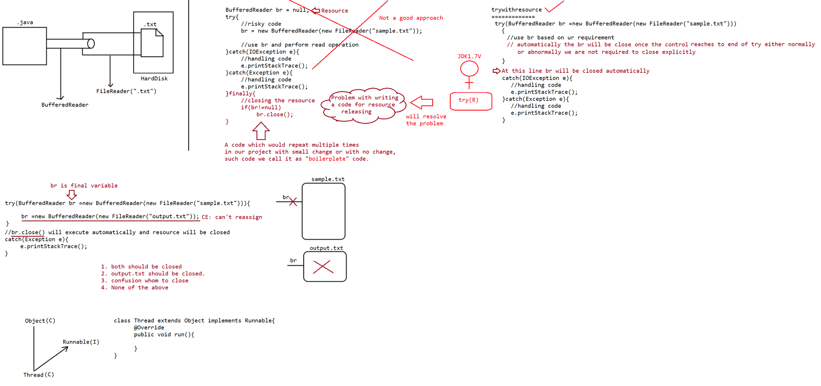
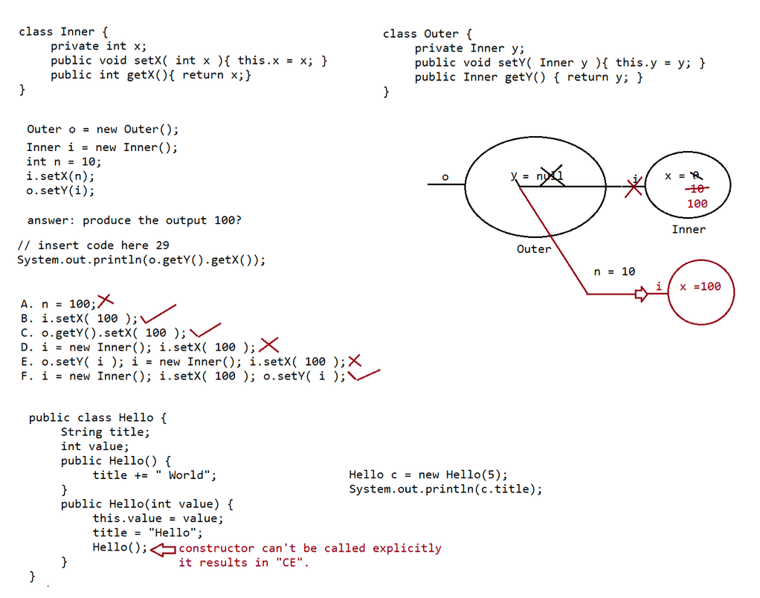

053 Multi Threading in Java
Q>
class Payload {
private int weight;
public Payload (int w) { weight = w; }
public void setWeight(int w) { weight = w; }
public String toString() { return Integer.toString(weight); }
}
public class TestPayload {
static void changePayload(Payload p) {
p.setWeight(420);
/* insert code */ //Line 12
}
public static void main(String[] args) {
Payload p = new Payload(200);// weight = 200
p.setWeight(1024);//weight = 1024
changePayload(p);
System.out.println("p is " + p);
}
}
Which code fragment, inserted at the end of line 12, produces the output p is 420?
A. p.setWeight(420);
B. p.changePayload(420);
C. p = new Payload(420);
D. Payload.setWeight(420);
E. p = Payload.setWeight(420);
Answer: A
Q>
public static void test(String str) {
int check = 4;
if (check = str.length()) {
System.out.print(str.charAt(check -= 1) +", ");
} else {
System.out.print(str.charAt(0) + ", ");
}
}
and the invocation:
test("four");
test("tee");
test("to");
What is the result?
A. r, t, t,
B. r, e, o,
C. Compilation fails.
D. An exception is thrown at runtime.
Answer: C
Question
abstract class C1 {
public C1() { System.out.print(1); }
}
class C2 extends C1 {
public C2() { System.out.print(2); }
}
class C3 extends C2 {public C3() { System.out.println(3); }
}
public class Ctest {
public static void main(String[] a) { new C3(); }
}
What is the result?
A. 3
B. 23
C. 32
D. 123
E. 321
F. Compilation fails.
G. An exception is thrown at runtime.
Answer: D
Q>
Given:
class One {
public One foo() {
return this;
}
}
class Two extends One {
public One foo() {
return this;
}
}
class Three extends Two {
// insert method here
}
Which two methods, inserted individually, correctly complete the Three class?
(Choose two.)
A. public void foo() {}
B. public int foo() { return 3; }
C. public Two foo() { return this; }
D. public One foo() { return this; }
E. public Object foo() { return this; }
Answer : C,D
Parent
|
| => IS-A relationship
Child
Covariant return types
==================
Object
|
String
Number
|
Integer
Q>
Given:public interface A { public void m1(); }
class B implements A { } //CE
class C implements A { public void m1() { } }
class D implements A { public void m1(int x) { } }//CE
abstract class E implements A { }
abstract class F implements A { public void m1() { } }
abstract class G implements A { public void m1(int x) { } }
What is the result?
A. Compilation succeeds.
B. Exactly one class does NOT compile.
C. Exactly two classes do NOT compile.
D. Exactly four classes do NOT compile.
E. Exactly three classes do NOT compile
Answer: C
Q>
Given:
1. class TestA {
2. public void start() { System.out.println("TestA"); }
3. }
4. public class TestB extends TestA {
5. public void start() { System.out.println("TestB"); }//overriden method
6. public static void main(String[] args) {
7. ((TestA)new TestB()).start();
8. }
9. }
What is the result?
A. TestA
B. TestB
C. Compilation fails.
D. An exception is thrown at runtime.
Answer: B
Q>
Given:
class Line {
public class Point {
public int x, y;
public Point getPoint() {
return new Point();
}
}
}
class Triangle {
public Triangle() {
// insert code here line 16
}
}Which code, inserted at line 16, correctly retrieves a local instance of a Point
object?
A. Point p = Line.getPoint();
B. Line.Point p = Line.getPoint();
C. Point p = (new Line()).getPoint();
D. Line.Point p = (new Line()).getPoint()
Answer: D
Syllabus
========
1.Introduction.
2. The ways to define, instantiate and start a new Thread.
1. By extending Thread class
2. By implementing Runnable interface
3. Thread class constructors
4. Thread priority
5. Getting and setting name of a Thread.
6. The methods to prevent(stop) Thread execution.
1. yield()
2. join()
3. sleep()
7. Synchronization.
8. Inter Thread communication.
9. Deadlock
10. Daemon Threads.
11. Various Conclusion
1. To stop a Thread
2. Suspend & resume of a thread
3. Thread group
4. Green Thread
5. Thread Local
12. Life cycle of a Thread
MulitTasking
===========
Executing several task simultaneously is the concept of multitasking.
There are 2 types of Multitasking.
a. Process based multitasking
b. Thread based multitasking.
Process based multitasking
==========================
Executing several tasks simultaneously where each task is a seperate independent
process such type of multitasking is called
"process based multitasking".
eg:: typing a java pgm
listening to a song
downloading the file from internet
Process based multitasking is best suited at "os level".
Thread based multitasking
=============================
=>Executing several tasks simulatenously where each task is a seperate independent
part of the same Program, is called
"Thread based MultiTasking".
Each independent part is called "Thread".
1. This type of multitasking is best suited at "Programatic level".
The main advantages of multitasking is to reduce the response time of the
system and to improve the performance.
2. The main important application areas of multithreading are
a. To implement mulitmedia graphics
b. To develop web application servers(will learn in JEE)
c. To develop video gamesd. To develop animations
3. Java provides inbuilt support to work with threads through API called
Thread,Runnable,ThreadGroup,ThreadLocal,...
4. To work with multithreading, java developers will code only for 10% remaining
90% java API will take care..
What is thread?
A. Seperate flow of execution is called "Thread".
if there is only one flow then it is called "SingleThread" programming.
For every thread there would be a seperate job.
B. In java we can define a thread in 2 ways
a. Implementing Runnable interface
b. extending Thread class
1. Extending Thread class
=> we can create a Thread by extending a Thread.
class MyThread extends Thread{
@Override
public void run(){
for(int i=0;i<10;i++)
System.out.println("child thread");
}
}
defining a thread(writing a class and extending a Thread)
job a thread(code written inside run())
class ThreadDemo{
public static void main(String... args){
MyThread t =new MyThread();//Thread instantiation
t.start();//starting a thread
;;;; // At this line 2 threads are there
for(int i=1;i<=5;i++)
System.out.println("Main Thread");
}
}
Behind the scenes
1. Main thread is created automatically by JVM.
2. Main thread creates child thread and starts the child thread.
ThreadScheduler
==============
If multiple threads are waiting to execute,then which thread will execute 1st is
decided by ThreadScheduler which is part of
JVM.
In case of MultiThreading we can't predict the exact output only possible output
we can expect.
Since jobs of threads are important,we are not interested in the order of
execution it should just execute such that
performance should be improved.
case2: diff b/w t.start() and t.run()
if we call t.start() and seperate thread will be created which is
responsible to execute run() method.if we call t.run(), no seperate thread will be created rather the method
will be called just like normal method by main
thread.
if we replace t.start() with t.run() then the output of the program would be
child thread
child thread
child thread
child thread
child thread
child thread
child thread
child thread
child thread
child thread
main thread
main thread
main thread
main thread
main thread
main thread
main thread
main thread
main thread
main thread
case3:: Importance of Thread class start() method
For every thread, required mandatory activities like registering the thread with
Threadscheduler will be taken care by
Thread class start() method and programmer is responsible of just doing the job of
the Thread inside run() method.
start() acts like an assistance to programmer.
public void start()
{
register thread with ThreadScheduler
All other mandatory low level activities
invoke or calling run() method.
}
We can conclude that without executing Thread class start() method there is no
chance of starting a new Thread in java.
Due to this start() is considered as heart of MultiThreading.
case4:: If we are not overriding run() method
If we are not Overriding run() method then Thread class run() method will be
executed which has empty implementation and
hence we wont get any output.
eg::
class MyThread extends Thread{}
class ThreadDemo{
public static void main(String... args){
MyThread t=new MyThread();
t.start();
}
}
It is highly recomended to override run() method, otherwise don't go for
MultiThreading concept.

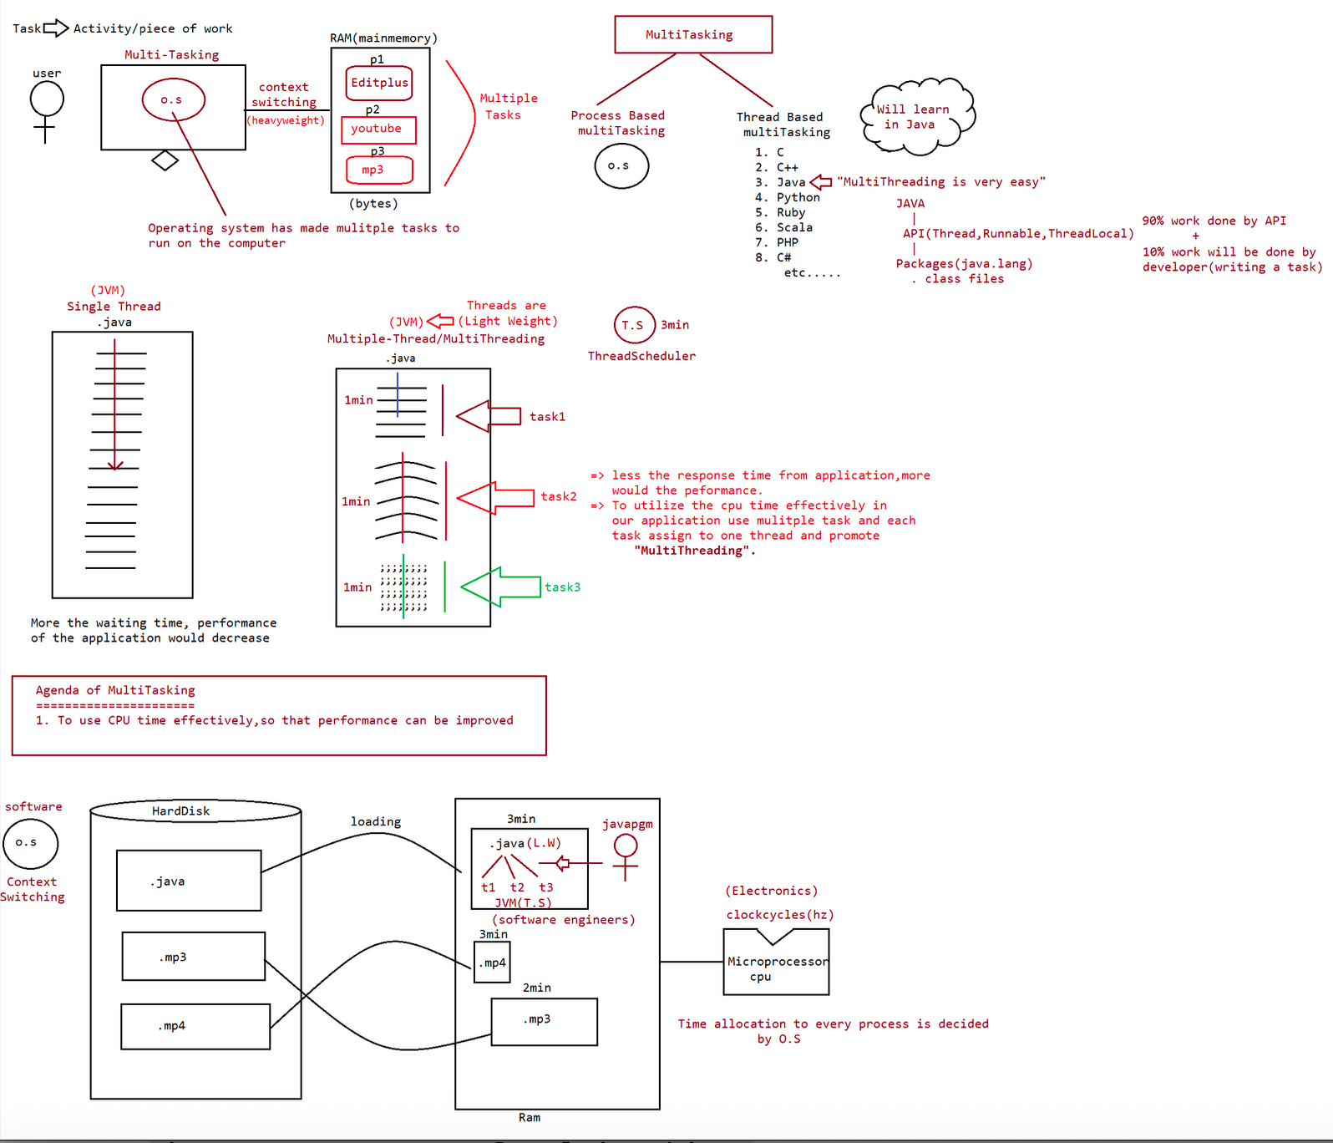
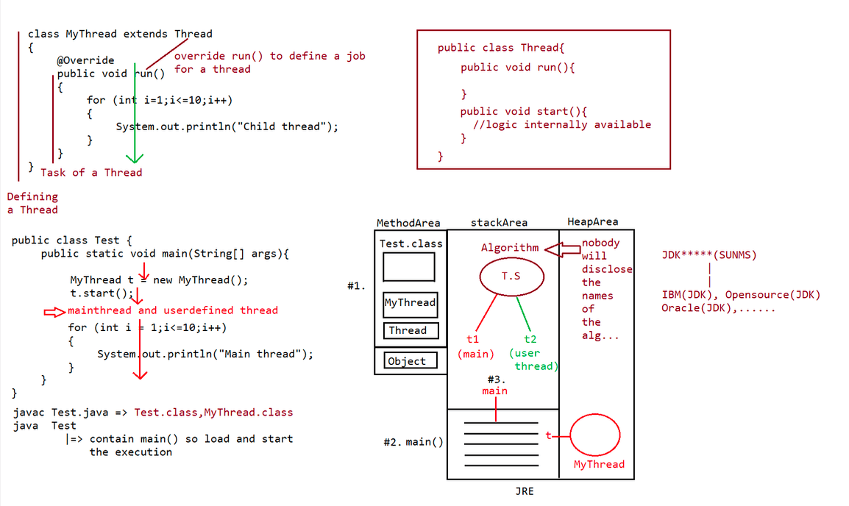

054 Multithreading part 02
case5:Overloading of run() method
we can overload run() method but Thread class start() will always call run() with
zero argument.
if we overload run method with arguments, then we need to explicitly call argument
based run method and it will be executed just like
normal method.
eg::
class MyThread extends Thread{
public void run(){
System.out.println("no arg method");
}
public void run(int i){
System.out.println("zero arg method");
}
}
class ThreadDemo{
public static void main(String... args){
MyThread t=new MyThread();
t.start();
}
}
Output:: NO arg method.
Case6::Overriding of start() method
If we override start() then our start() method will be executed just like normal
method,but no new Thread will be
created and no new Thread will be started.
eg#1.
class MyThread extends Thread{
public void run(){
System.out.println("no arg method");
}
public void start(){
System.out.println("start arg method");
}
}
class ThreadDemo{
public static void main(String... args){
MyThread t=new MyThread();
t.start();
}
}
Output:: start arg method
It is never recomended to override start() method.
case7::
class MyThread extends Thread{
public void run(){
System.out.println("run method");
}
public void start(){
System.out.println("start method");
}
}
class ThreadDemo{
public static void main(String... args){
MyThread t=new MyThread();t.start();
System.out.println("Main method");
}
}
Output::
MainThread
a. Main method
b. start method.
eg#2.
class MyThread extends Thread{
public void start(){
super.start();
System.out.println("start method");
}
public void run(){
System.out.println("run method");
}
}
class ThreadDemo{
public static void main(String... args){
MyThread t=new MyThread();
t.start();
System.out.println("Main method");
}
}
Output::
MainThread
a. Main method
b. start method
UserDefinedThread
a. run method
case8:: Life cycle of a Thread
MyThread t=new MyThread(); // Thread is in born state
t.start(); //Thread is in ready/runnable state
if Thread scheduler allocates CPU time then we say thread entered into Running
state.
if run() is completed by thread then we say thread entered into dead state.
=> Once we created a Thread object then the Thread is said to be in new state or
born state.
=> Once we call start() method then the Thread will be entered into Ready or
Runnable state.
=> If Thread Scheduler allocates CPU then the Thread will be entered into running
state.
=> Once run() method completes then the Thread will entered into dead state.
case9::
After starting the Thread, we are not supposed to start the same Thread again,then
we say Thread
is in "IllegalThreadStateException".
MyThread t=new MyThread(); // Thread is in born state
t.start(); //Thread is in ready state
....
....
t.start(); //IllegalThreadStateExceptionCreation of Thread using Runnable interface
====================================
1. Creating a Thread using java.lang.Thread class
a. use start() from Thread class
b. override run() and define the job of the Thread.
2. Creation of a Thread requirement to SUNMS is an SRS
interface Runnable{
void run();
}
class Thread implements Runnable{ // Adapter class
public void start(){
1. Register the thread with ThreadScheduler
2. All other mandatory low level activities(memory level)
3. invoke or call run() method
}
public void run(){
//job for a thread
}
}
shortcuts of eclipse
ctrl+shift+T => To open a defnition of any class
ctrl + o => To list all the methods of the class
Note:
public java.lang.Thread();
|=> thread class start(), followed by thread class
run()
public java.lang.Thread(java.lang.Runnable);
|=> thread class start(), followed by implementation
class of Runnable run()
Defining a Thread by implementing Runnable Interface
===================================================
public interface Runnable{
public abstract void run();
}
public class Thread implements Runnable{
public void start(){
1. register Thread with ThreadScheduler
2. All other mandatory low level activites
3. invoke run()
}
public void run(){
//empty implementation
}
}
eg::1
class MyRunnable implements Runnable{
@Override
public void run(){
for(int i=1;i<=10;i++)
System.out.println("child thread");
}
}
public class ThreadDemo{public static void main(String... args){
MyRunnable r=new MyRunnable();
Thread t=new Thread(r);//call MyRunnable run()
t.start();
for(int i=1;i<=10;i++)
System.out.println("main thread");
}
}
Output::
MainThread
a. main thread
....
....
ChildThread
a. child thread
...
...
...
Case study
=========
MyRunnable r=new MyRunnable();
Thread t1=new Thread();
Thread t2=new Thread(r);
case1: t1.start()
Thread class run()
output
mainthread
A new thread will be created,which is responsible for executing
main thread
main thread
main thread
main thread
main thread
case2: t2.start()
MyRunnable run()
output
mainthread
A new thread will be created,which is responsible for executing
main thread
main thread
main thread
main thread
main thread
userdefinedthread
child thread
child thread
child thread
child thread
child thread
case3: t1.run()
No new thread will be created,but Thread class run() will be
executed just like normal method call.output
mainthread
main thread
main thread
main thread
main thread
main thread
case4: t2.run()
No new thread will be created,but MyRunnable class run() will be
executed just like normal method call.
output
mainthread
child thread
child thread
child thread
child thread
child thread
main thread
main thread
main thread
main thread
main thread
case5: r.start()
It results in CompileTime Error
case6. r.run()
No new thread will be created,but MyRunnable class run() will be
executed just like normal method call.
output
mainthread
child thread
child thread
child thread
child thread
child thread
main thread
main thread
main thread
main thread
main thread
MyRunnable r=new MyRunnable();
Thread t1=new Thread();
Thread t2=new Thread(r);
case1: t1.start()
case2: t2.start()
case3: t2.run()
case4: t1.run()
case5: r.start()
case6: r.run()
In which of the above cases a new Thread will be created which is responsible for
the execution of MyRunnable run() method ?t2.start();
In which of the above cases a new Thread will be created ?
t1.start();
t2.start();
In which of the above cases MyRunnable class run() will be executed?
t2.start();
t2.run();
r.run();
Different approach for creating a Thread?
A. extending Thread class
B. implementing Runnable interface
Which approach is the best approach?
a. implements Runnable interface is recomended becoz our class can extend other
class through
which inheritance benift can brought in to our class.
Internally performance and memory level is also good when we work with
interface.
b. if we work with extends feature then we will miss out inheritance benefit becoz
already our
class has inherited the feature from "Thread class", so we normally don't
prefere
extends approach rather implements approach is used in real time for working
with "MultiThreading".
Various Constructors available in Thread class
==============================================
a. Thread t=new Thread()
b. Thread t=new Thread(Runnable r)
c. Thread t=new Thread(String name)
d. Thread t=new Thread(Runnable r,String name)
e. Thread t=new Thread(ThreadGroup g, String name);
f. Thread t=new Thread(ThreadGroup g, Runnable r);
g. Thread t=new Thread(ThreadGroup g, Runnable r,String name);
h. Thread t=new Thread(ThreadGroup g, Runnable r,String name,long stackSize);
Alternate approach to define a Thread(not recomended)
=====================================================
class MyThread extends Thread{
public void run(){
System.out.println("child thread");
}
}
class ThreadDemo {
public static void main(String... args){
MyThread t=new MyThread();
Thread t1=new Thread(t);
t1.start();
System.out.println("main thread");
}
}
Output::2 threads are created
MainThreadmain thread
ChildThread
child thread
internally related
==================
Runnable
^
|
Thread
^
|
MyThread
Names of the Thread
===================
Internally for every thread,there would be a name for the thread.
a. name given by jvm
b. name given by the user.
eg::
class MyThread extends Thread{
}
public class TestApp{
public static void main(String... args){
System.out.println(Thread.currentThread().getName());//main
MyThread t=new MyThread();
t.start();
System.out.println(t.getName());//Thread-0
Thread.currentThread().setName("Yash");//Yash
System.out.println(Thread.currentThread().getName());//Yash
System.out.println(10/0);
//Exception in thread "yash" java.lang.ArithmeticException:/by zero
TestApp.main()
}
}
=> It is also possible to change the name of the Thread using setName().
=> It is possible to get the name of the Thread using getName().
methods
public final String getName();
public final void setName(String name);
eg#2.
class MyThread extends Thread{
@Override
public void run(){
System.out.println("run() executed by Thread ::
"+Thread.currentThread().getName());
}
}
public class TestApp{
public static void main(String... args){
MyThread t=new MyThread();t.start();
System.out.println("main() executed by Thread ::
"+Thread.currentThread().getName());
}
}
Output:: run() executed by Thread:: Thread-0
main() executed by Thread:: main

Q>
public class Breaker {
static String o = "";
public static void main(String[] args) {
z: o = o + 2;
for (int x = 3; x < 8; x++) {
if (x == 4)
break;
if (x == 6)
break z;
o = o + x;
}
System.out.println(o);
}
}
What is the result?
A. 23
B. 234
C. 235
D. 2345
E. 2357
F. 23457
G. Compilation fails.
Answer: G
Q>
public class Tahiti {
Tahiti t;
public static void main(String[] args) {
Tahiti t = new Tahiti();
Tahiti t2 = t.go(t);
t2 = null;
// more code here 11
}
Tahiti go(Tahiti t) {
Tahiti t1 = new Tahiti();
Tahiti t2 = new Tahiti();
t1.t = t2;
t2.t = t1;
t.t = t2;
return t1;
}
}
A. 0
B. 1
C. 2
D. 3
Answer: 0(island of isolation)
Q>
When line 11 is reached, how many objects are eligible for garbage collection?
public class ItemTest {
private final int id;
public ItemTest(int id) {
this.id = id;
}public void updateId(int newId) {
id = newId;
}
public static void main(String[] args) {
ItemTest fa = new ItemTest(42);
fa.updateId(69);
System.out.println(fa.id);
}
}
What is the result?
A. Compilation fails.
B. An exception is thrown at runtime.
C. The attribute id in the ItemTest object remains unchanged.
D. The attribute id in the ItemTest object is modified to the new value.
E. A new ItemTest object is created with the preferred value in the id attribute.
Answer: A
Q>
class Foo {
private int x;
public Foo( int x ){ this.x = x;}
public void setX( int x ) { this.x = x; }
public int getX(){ return x;}
}
public class Gamma {
static Foo fooBar(Foo foo) {
foo = new Foo(100);
return foo;
}
public static void main(String[] args) {
Foo foo = new Foo( 300 );
System.out.println( foo.getX() + "-");
Foo fooFoo = fooBar(foo);
System.out.println(foo.getX() + "-");
System.out.println(fooFoo.getX() + "-");
foo = fooBar( fooFoo);
System.out.println( foo.getX() + "-");
System.out.println(fooFoo.getX());
}
}
What is the output of the program shown in the exhibit?
A. 300-100-100-100-100
B. 300-300-100-100-100
C. 300-300-300-100-100
D. 300-300-300-300-100
Answer: B
Q>
interface Fish {}
class Perch implements Fish {}
class Walleye extends Perch {}
class Bluegill {}
public class Fisherman {
public static void main(String[] args) {
Fish f = new Walleye();
Walleye w = new Walleye();Bluegill b = new Bluegill();
if (f instanceof Perch)
System.out.print("f-p ");
if (w instanceof Fish)
System.out.print("w-f ");
if (b instanceof Fish)
System.out.print("b-f ");
}
}
What is the result?
A. w-f
B. f-p w-f
C. w-f b-f
D. f-p w-f b-f
E. Compilation fails.
F. An exception is thrown at runtime
Answer: B

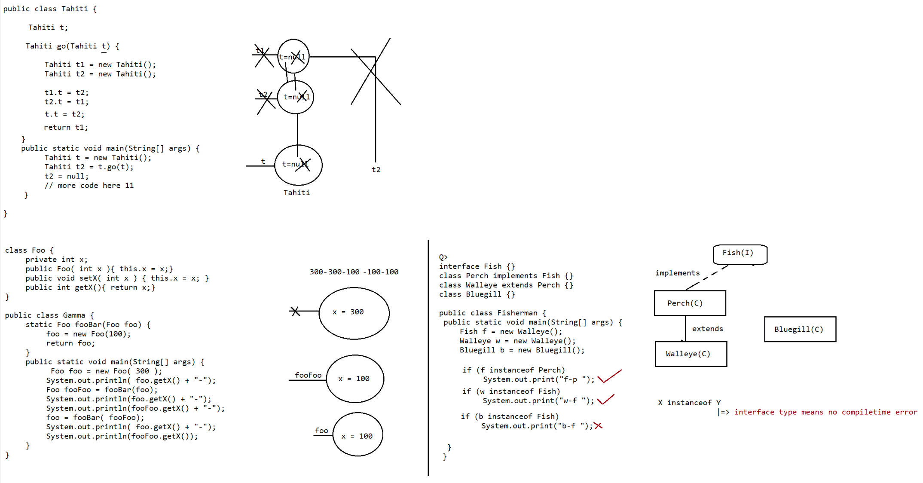
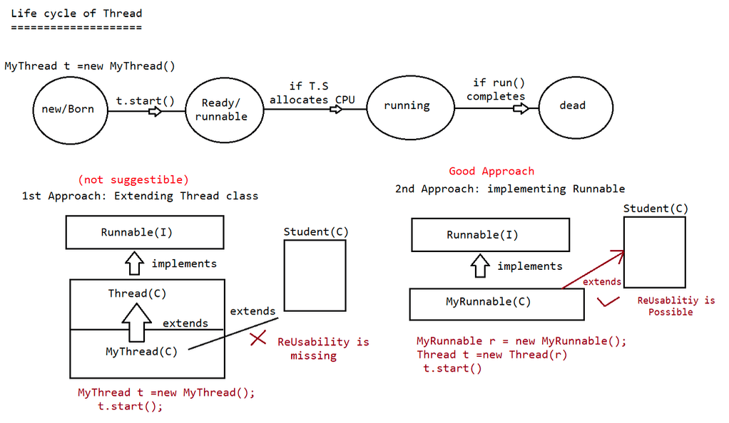

055 DOUBT

Q>
giving column
way to do ?
this.
sir can we write query like "insert into student()values(?,?)"; I mean without
names when we are using preparedStatement and if we write like this ... is it right
i am asking this because yesterday one discussion is going on discord regarding
answer: insert into student values(?,?),yes possible.
Q> Why JVM always call the main method having String[] args only not other
overloaded methods?
Answer: jvm is designed by SUNMS team, to make a call to method with the following
signature only.
eg: public static void main(String[] args){}
Q> isInstance () i have a confusion what does he do?
System.out.println("sachin" instanceof String);//type(String) known from
begining so use instanceof
isInstance() will work like instanceof only but the rule is the "type" is not
known from begining.
Q> Why can't we make a constructor final,static
construcor => means object creation
static and final => not meant for Objects so we can't write.
Q> In what all condition a toString() method is triggered
class Test{}
System.out.println(new Test());//new Test().toString()
Test t =new Test();
System.out.println(t);// t.toString() is called
Q> what are max no of argument that can be passed in command line to the array?
Answer. No limit
Q> Sir, the OUT parameters is something I'm still a bit confused.
DELIMITER $$
USE `enterprisejavabatch`$$
DROP PROCEDURE IF EXISTS `getStudentsById`$$
CREATE DEFINER=`root`@`localhost` PROCEDURE `getStudentsById`(IN id INT,OUT stdName
VARCHAR(20),OUT stdAddr VARCHAR(20))
BEGIN
SELECT sname,saddr INTO stdName,stdAddr
FROM student
WHERE sid = id;
END$$
DELIMITER ;
call getStudentsById(7,@stdName,@stdAddr)
select @stdName as 'name'
select @stdAddr as 'saddr'
hello sir, is this any situation when I get a waiting state while asking for a
connection object. I mean how many connection objects in the connection pool?Answer: depends on DB vendor
Sir, Please explain JNI error and how it is caused
class Test{}
|
javac Test.java(eg: jdk17v)
|
Test.class
java Test(eg: jdk8V)
|
output(JNI error)
Q>
class A {
}
public boolean is(Object o) {
return (o == this);
}
A someA = new A();
A anotherA = new A();
someA.is(someA); // returns true
someA.is(anotherA); // why returns false
becoz comparison is on different object, not on same object
Q>
this confusion
============
public class MyThisTest {
private int a;//42
public MyThisTest() {
this(42); // calls the other constructor
}
public MyThisTest(int a) {
this.a = a; // assigns the value of the parameter a to the field of the same
name
}
public void frobnicate() {
int a = 1; ;;local variable
System.out.println(this); //prints MyThisTest a=42 why?
}
}
public String toString() {
return "MyThisTest a=" + a; // refers to the field a
}
Q>
interface a{
}
void add(int a,String name);public class LamdaEx1 {
public static void main(String[] args) {
a t=(a,name)->{
String na=name;
int aa=a;
System.out.println("hi");
};
t.add(10,"sourav");
}
}
now code will work.
MyRunnable r = new MyRunnable();
Thread t1 =new Thread();
Thread t2 =new Thread(r);
t1.start() //new thread will be created, and thread class run() will be called
t2.start()// new thread will be created and MyRunnable run() will be called

056 Multithreading part 03
ThreadPriorities
================
For every Thread in java has some priority.
valid range of priority is 1 to 10,it is not 0 to 10.
if we try to give a differnt value the it would result in
"IllegalArgumentException".
Thread.MIN_PRIORITY = 1
Thread.MAX_PRIORITY = 10
Thread.NORM_PRIORITY = 5
Thread class does not have priorities is Thread.LOW_PRIORITY,Thread.HIGH_PRIORITY.
Thread scheduler allocates cpu time based on "Priority".
If both the threads have the same priority then which thread will get a chance as
a pgm we can't
predict becoz it is vendor dependent.
We can set and get priority values of the thread using the following methods
a. public final void setPriority(int priorityNumber)
b. public final int getPriority()
The allowed priorityNumber is from 1 to 10,if we try to give other values it woudl
result in
"IllegalArgumentException".
System.out.println(Thread.currentThread().setPriority(100);//IllegalArgumentExcepti
on.
DefaultPriority
==============
The default priority for only main thread is "5",where as for other threads
priority will be
inherited from parent to child.
Parent Thread priority will be given as Child Thread Priority.
eg#1.
class MyThread extends Thread{}
public class TestApp{
public static void main(String... args){
System.out.println(Thread.currentThread().getPriority());//5
Thread.currentThread().setPriority(7);
MyThread t= new MyThread();
System.out.println(Thread.currentThread().getPriority());//7
}
}
reference
=========
Thread
^
|extends
|
MyThread
MyThread is creating by "mainThread", so priority of "mainThread" will be shared
as a priority for "MyThread".
eg#2.
class MyThread extends Thread{
@Override
public void run(){
for (int i=1;i<=5 ;i++ ){
System.out.println("child thread");}
}
}
public class TestApp{
public static void main(String... args){
MyThread t= new MyThread();
t.setPriority(7);//line -1
t.start();
for (int i=1; i<=5; i++){
System.out.println("main thread");
}
}
}
Since priority of child thread is more than main thread, jvm will execute child
thread first
whereas for the parent thread priority is 5 so it will get last chance.
if we comment line-1, then we can't predict the order of execution becoz both the
threads have same priority.
Some platform won't provide proper support for Thread priorities.
eg:: windows7,windows10,...
We can prevent Threads from Execution
a. yield()
b. sleep()
c. join()
yield() => It causes to pause current executing Thread for giving chance for
waiting Threads of
same priority.
If there is no waiting Threads or all waiting Threads have low priority
then
same Thread can continue its execution.
If all the threads have same priority and if they are waiting then
which thread will
get chance we can't expect, it depends on ThreadScheduler.
The Thread which is yielded, when it will get the chance once again
depends on the
mercy on "ThreadScheduler" and we can't expect exactly.
public static native void yield()
MyThread t= new MyThread() //new state or born state
t.start() // enter into ready state/runnable state
if ThreadScheduler allocates processor then enters into running state.
a. if running Thread calls yield() then it enters into runnable state.
if run() is finished with execution then it enters into dead state.
eg#1.
class MyThread extends Thread{
@Override
public void run(){
for (int i=1;i<=5 ;i++ ){
System.out.println("child thread");
Thread.yield();//line-1
}
}}
public class TestApp{
public static void main(String... args){
MyThread t= new MyThread();
t.start();
for (int i=1;i<=5 ;i++ ){
System.out.println("Parent Thread");
}
}
}
Note::
If we comment line-1, then we can't expect the output becoz both the threads have
same priority then which
thread the ThreadScheduler will schedule is not in the hands of programmer but if
we don't comment line-1,
then there is a possibility of main thread getting more no of times, so main thread
execution is faster than
child thread will get chance.
Note: Some platforms wont provide proper support for yield(),becuase it is getting
the execution
code from other language prefereably from 'C'.
b. join()
If the thread has to wait untill the other thread finishes its execution
then we need
to go for join().
if t1 executes t2.join() then t1 should should wait till t2 finishes its
execution.
t1 will be entered into waiting state untill t2 completes, once t2 completes
then
t1 can continue with its execution.
eg#1.
venue fixing =====> t1.start()
wedding card printing =====> t2.start()=====> t1.join()
wedding card distrubution =====> t3.start()=====> t2.join()
Prototype of join()
===================
public final void join() throws InterruptedException
public final void join(long ms)throws InterruptedException
public final void join(long ms,int ns)throws InterruptedException
Note: While one thread is in waiting state and if one more thread interupts then it
would result
always be
handled.
in "InteruptedException".InteruptedException is checkedException which should
Thread t =new Thread();//new/born state
t.start();//ready/runnable state
-> If T.S allocates cpu time then Thread enters into running state
-> If currently executing Thread invokes t.join()/t.join(1000),t.join(1000,100),
then it
would enter into waiting state.
-> If the thread finishes the execution/time expires/interupted then it would come
back to
ready state/runnable state.-> If run() is completed then it would enter into dead state.
eg#1.
class MyThread extends Thread{
@Override
public void run(){
for (int i=1;i<=10 ;i++ ){
System.out.println("Sita Thread");
try{
Thread.sleep(2000);
}
catch (InterruptedException e){
}
}
}
}
public class Test3 {
public static void main(String... args)throws InterruptedException{
MyThread t=new MyThread();
t.start();
t.join(10000);//line-n1
for (int i=1;i<=10;i++ ){
System.out.println("rama thread");
}
}
}
=> If line-n1 is commented then we can't predict the output becoz it is the duty of
the T.S to assign C.P.U time
=> If line-n1 is not commented, then rama thread(main thread) will enter into
waiting state till
sita thread(child thread) finishes its execution.
Output
2 Threads
a. Child Thread
sita thread
sita thread
....
b. Main Thread
rama thread
rama thread
....
Waiting of Child Thread untill Completing Main Thread
=====================================================
we can make main thread to wait for child thread as well as we can make child
thread also to wait for main thread.
eg#1.
class MyThread extends Thread{
static Thread mt;
@Override
public void run(){
try{
mt.join();
}
catch (InterruptedException e){
}for (int i=1;i<=10 ;i++ ){
System.out.println("child thread");
}
}
}
public class Test3 {
public static void main(String... args)throws InterruptedException{
MyThread.mt=Thread.currentThread();
MyThread t=new MyThread();
t.start();
for (int i=1;i<=10;i++ ){
System.out.println("main thread");
Thread.sleep(2000);//20sec sleep
}
}
}
Output
2 Threads(MainThread,ChildThread)
MainThread
a. main thread
....
....
ChildThread
a. child thread
....
....
eg#2.
class MyThread extends Thread{
static Thread mt;
@Override
public void run(){
try{
}
}
}
mt.join();
catch (InterruptedException e){
for (int i=1;i<=10 ;i++ ){
System.out.println("child thread");
}
}
public class Test3 {
public static void main(String... args)throws InterruptedException{
MyThread.mt=Thread.currentThread();
MyThread t=new MyThread();
t.start();
t.join();for (int i=1;i<=10;i++ ){
System.out.println("main thread");
Thread.sleep(2000);//20sec sleep
}
}
}
output:
2 threads(Main,child thread)
main thread
;;;;
;;;;
childthread
Note::
"deadlock".
If both the threads invoke t.join(),mt.join() then the program would result in
eg#3.
public class Test3 {
public static void main(String... args)throws InterruptedException{
Thread.currentThread().join();
}
}
Output:: Deadlock, becoz main thread is waiting for the main thread itself.
sleep()
======
then we
should go for sleep().
If a thread dont' want to perform any operation for a particular amount of time
Signature
public static native void sleep(long ms) throws InterruptedException
public static void sleep(long ms,int ns) throws InterruptedException
every sleep method throws InterruptedException, which is a checkedexception so we
should compulsorily handle the exception using
try catch or by throws keyword otherwise it would result in compile time error.
Thread t=new Thread(); //new or born state
t.start() // ready/runnable state
=> If T.S allocates cpu time then it would enter into running state.
=> If run() completes then it would enter into dead state.
=> If running thread invokes sleep(1000)/sleep(1000,100) then it would enter into
Sleeping state
=> If time expires/ if sleeping thread got interrupted then thread would come back
to
"ready/runnable state".
eg#1.
public class SlideRotator {
public static void main(String... args)throws InterruptedException{
for (int i=1;i<=10 ;i++ ){
System.out.println("Slide: "+i);
Thread.sleep(5000);}
}
}
Output::
Slide:: 1
Slide:: 2
Slide:: 3
Slide:: 4
Slide:: 5
Slide:: 6
Slide:: 7
Slide:: 8
Slide:: 9
Slide:: 10

Given:
class Converter {
public static void main(String[] args) {
Integer i = args[0]; // line 13
int j = 12;
System.out.println("It is " + (j == i) + " that j==i.");
}
}
What is the result when the programmer attempts to compile the code and run it with
the command
java Converter 12?
A. It is true that j==i.
B. It is false that j==i.
C. An exception is thrown at runtime.
D. Compilation fails because of an error in line 13.
Answer: D
QUESTION
Click the Exhibit button.
1. public class A {
2. public String doit(int x, int y){
3. return "a";
4. }
5.
6. public String doit(int... vals){
7. return "b";
8. }
9. }
Given:
25. A a = new A();
26. System.out.println(a.doit(4, 5));
What is the result?
A. Line 26 prints "a" to System.out.
B. Line 26 prints "b" to System.out.
C. An exception is thrown at line 26 at runtime.
D. Compilation of class A will fail due to an error in line 6.
Answer: A
Which two code fragments correctly create and initialize a static array of int
elements? (Choose two.)
A. static final int[] a = { 100,200 };
B. static final int[] a; static { a=new int[2]; a[0]=100; a[1]=200; }
C. static final int[] a = new int[2]{ 100,200 };
D. static final int[] a;
static void init() { a = new int[3]; a[0]=100; a[1]=200; }
if a variable is static an final the only place where we can initialize is
a. at the time of declaration
b. inside static block
static final int[] a = { 100,200 };
static{
a = new int[2];
a[0] = 100;
a[1] = 200;}
Q>
2. 3. 4. 5. 1. public class GoTest {
public static void main(String[] args) {
Sente a = new Sente(); a.go();
Goban b = new Goban(); b.go();
Stone c = new Stone(); c.go();
6. }
7. }
8.
9. class Sente implements Go {
10. public void go(){
11. System.out.println("go in Sente");
12. }
13.}
14.
15.class Goban extends Sente {
16. public void go(){
17. System.out.println("go in Goban");
18. }
19.
20.}
21.class Stone extends Goban implements Go{
22.}
23.
24.interface Go { public void go(); }
What is the result?
A. go in Goban go in Sente go in Sente
B. go in Sente go in Sente go in Goban
C. go in Sente go in Goban go in Goban
D. go in Goban go in Goban go in Sente
E. Compilation fails because of an error in line 17.
Answer: C
Q>
What statements are true about the following code? (Choose all that apply.)
public class Tail {}
public class Animal {//Animal HAS-A name
public String name;
}
HAS-A name
public class Canine extends Animal {//Canine IS-A Animal,Canine HAS-A Tail,Canine
public Tail tail;
}
public class Wolf extends Canine {}//Wolf IS-A Canine,Wolf IS-A Animal,Wolf HAS-A
Tail,Wolf HAS-A name
A. Wolf has-a name.
B. Wolf has-a Tail.
C. Wolf is-a Tail.
D. Wolf is-a Animal.
E. Canine is-a Wolf.
F. Animal has-a Tail.
Answer: A,B,D
Q>Which is a true statement about the following code?
public class IsItFurry {
static interface Mammal { }
static class Furry implements Mammal { }
static class Chipmunk extends Furry { }
public static void main(String[] args) {
Chipmunk c = new Chipmunk();
Mammal m = c;
Furry f = c;
int result = 0;
if (c instanceof Mammal) result += 1;
if (c instanceof Furry) result += 2;
if (null instanceof Chipmunk) result += 4;
System.out.println(result);
}
}
A. The output is 0.
B. The output is 3.
C. The output is 7.
D. c instanceof Mammal does not compile.
E. c instanceof Furry does not compile.
F. null instanceof Chipmunk does not compile.
Answer: B
Q>
Which of the following can be inserted in main?
public class Outer {
class Inner { }
public static void main(String[] args) {
// INSERT CODE HERE
}
}
A. Inner in = new Inner();
B. Inner in = Outer.new Inner();
C. Outer.Inner in = new Outer.Inner();
D. Outer.Inner in = new Outer().Inner();
E. Outer.Inner in = new Outer().new Inner();
F. Outer.Inner in = Outer.new Inner();
Answer: E

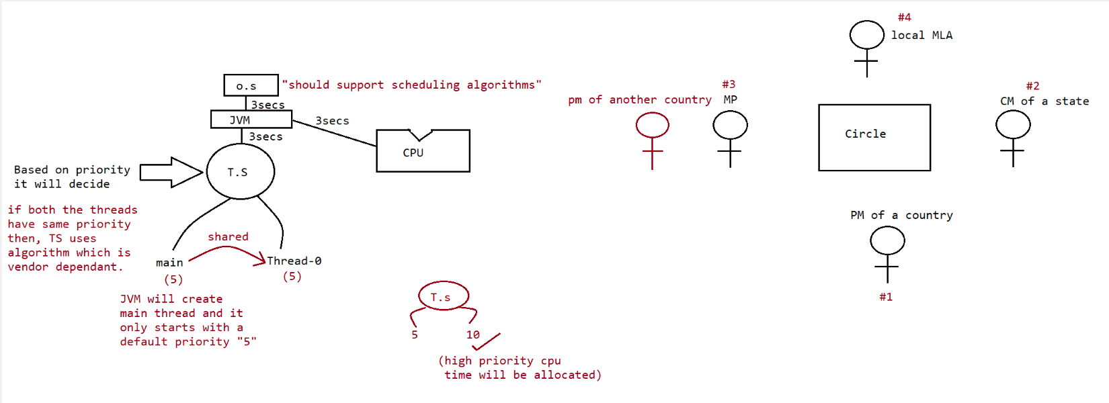
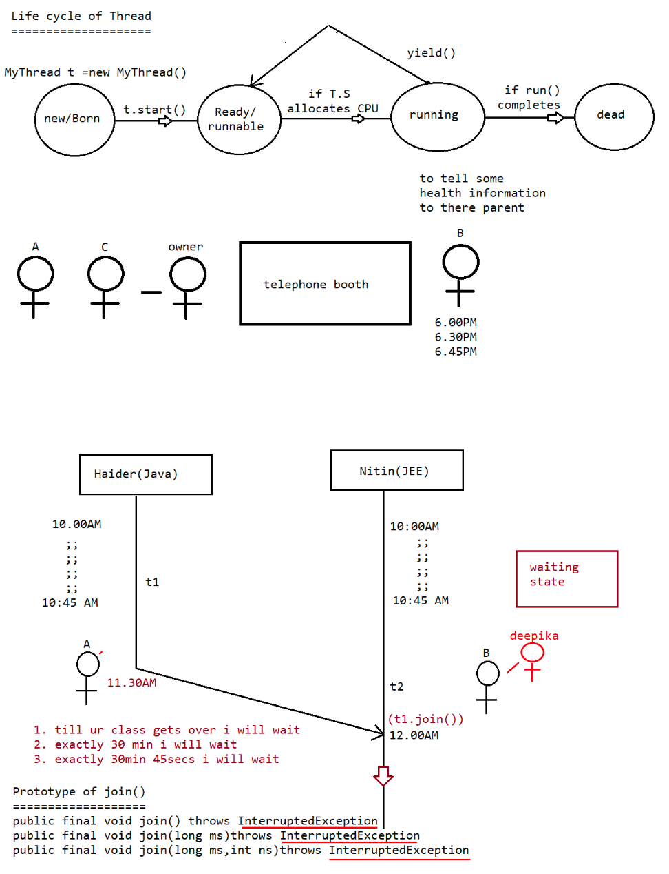
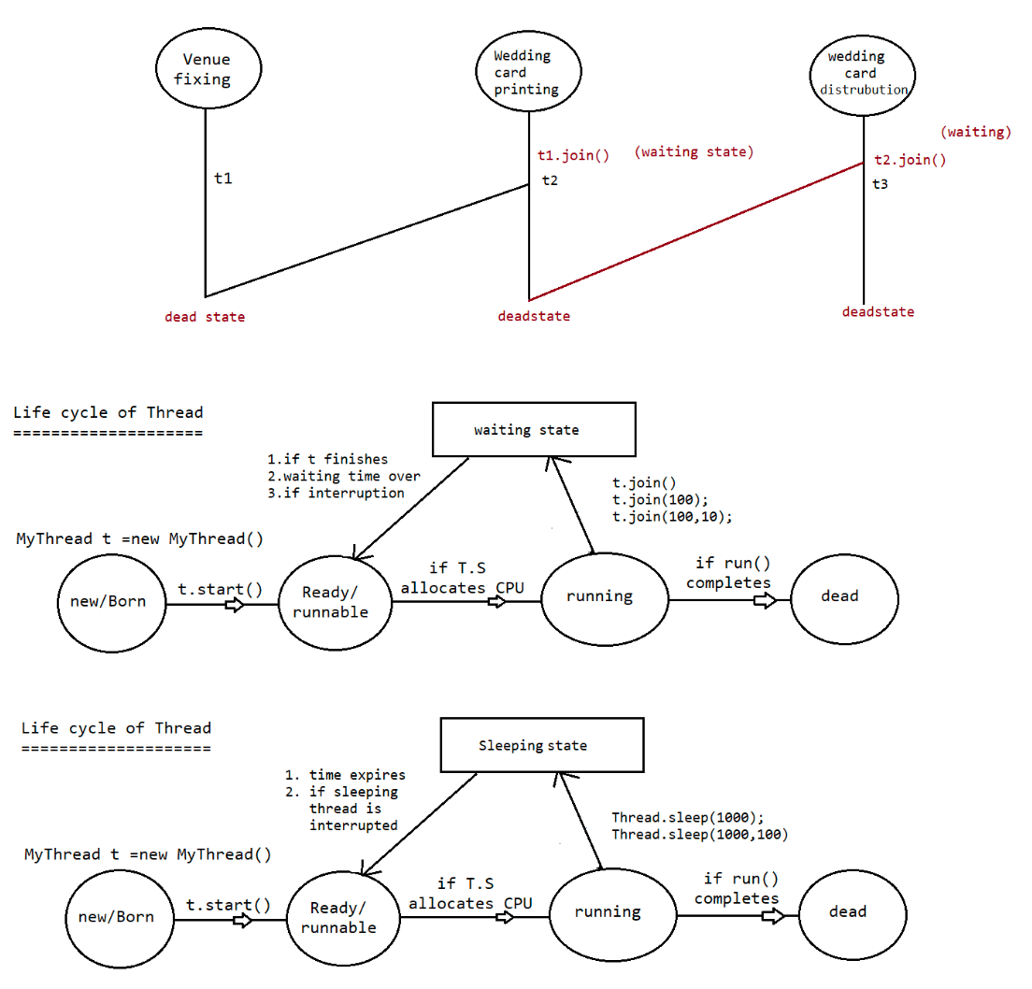
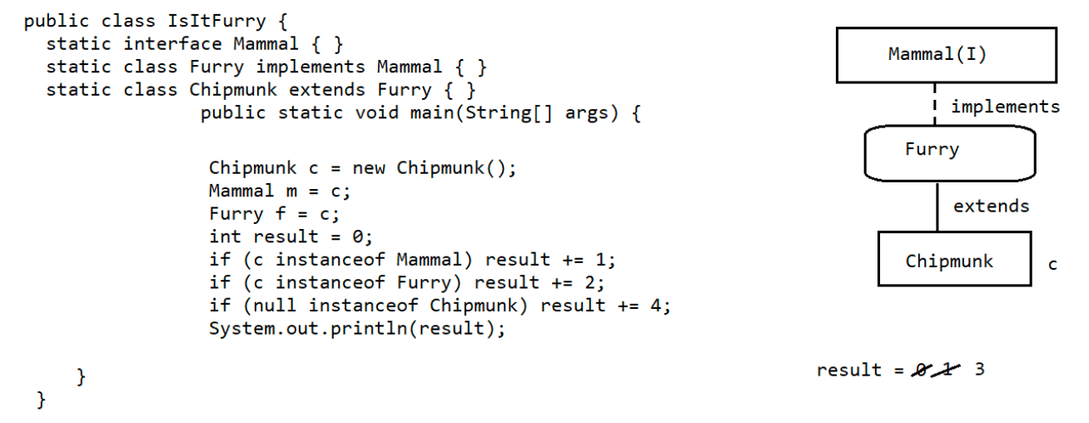

057 Multithreading part 04

Interupting a Thread
====================
public void interrupt()
=> If thread is in sleeping state or in waiting state we can interupt a thread.
eg#1.
class MyThread extends Thread{
@Override
public void run(){
try{
for (int i=1;i<=10;i++ ){
System.out.println("I am lazy thread");
Thread.sleep(2000);
}
}
catch (InterruptedException e){
System.out.println("I got interrupted");
}
}
}
public class Test3 {
public static void main(String... args)throws InterruptedException{
MyThread t=new MyThread();
t.start();
t.interrupt();//line-n1
System.out.println("End of Main...");
}
}
Scenario:: If a comment line-n1
2 thread
a. Main Thread
End of Main...
b. Child Thread
I am lazy thread
.....
.....
Scneario:: If t.interrupt() then
2 thread
a. Main Thread
main thread
b. Child Thread
I am lazy thread
I got interrupted
eg#2.
class MyThread extends Thread{
@Override
public void run(){
for (int i=1;i<=10000 ;i++ ){
System.out.println("I am lazy thread : "+i);
}System.out.println("I am entering into sleeping state");
try
{
Thread.sleep(2000);
}
catch (InterruptedException ie){
ie.printStackTrace();
}
}
}
public class TestApp {
public static void main(String[] args)throws InterruptedException {
MyThread t=new MyThread();
t.start();
t.interrupt();//line-n1
System.out.println("main thread");
}
}
line-n1 is commented then no problem
line-n1 is not commented, then interrupt() will wait till the Thread enters into
waiting state/sleeping state.
Note::
If thread is interrupting another thread, but target thread is not in waiting
state/sleeping state then there would be no exception.
interrupt() call be waiting till the target thread enters into waiting
state/sleeping state so this call wont be wasted.
once the target thread enters into waiting state/sleeping state then interrupt()
will interrupt and it causes the exception.
interrupt() call will be wasted only if the Thread does not enters into waiting
state/sleeping state.
yield() join() sleep()
================================
1) Purpose
yield()
To pause current executing Thread for giving the chance of remaining
waiting Threads of same priority.
join()
If a Thread wants to wait until completing some other Thread then we
should go for join.
sleep()
If a Thread don't want to perform any operation for a particular
amount of time then we should go for sleep() method.
2) Is it static
yield() yes
join() no
sleep() yes
3) Is it final?
yield() no
join() yessleep() no
4) Is it overloaded?
yield() no
join() yes
sleep() yes
5) Is it throws IE?
yield() no
join() yes
sleep() yes
6) Is it native method?
yield() yes
join() no
sleep()
sleep(long ms) -->native
sleep(long ms,int ns) -->non-native
Note::using lambda expression
Runnable r = ()-> {
for (int i = 1;i<=5 ; i++)
{
}
System.out.println("child thread");
};
Thread t = new Thread(r);
t.start();
using annonmyous inner class
=========================
new Thread(new Runnable(){
@Override
public void run(){
for (int i = 1;i<=5 ;i++ )
{
System.out.println("child thread");
}
}
}
).start();
synchronization
===============
1. synchronized is a keyword applicable only for methods and blocks
2. if we declare a method/block as synchronized then at a time only one thread
can execute that method/block on that
object.
3. The main advantage of synchronized keyword is we can resolve data
inconsistency problems.
4. But the main disadvantage of synchronized keyword is it increases waiting
time of the Thread and effects performance
of the system.
5. Hence if there is no specific requirement then never recommended to use
synchronized keyword.
6. Internally synchronization concept is implemented by using lock concept.
class X{synchronized void m1(){}
synchronized void m2(){}
void m3(){}
}
KeyPoints
=========
1. if t1 thread invokes m1() then on the Object X lock will applied.
2. if t2 thread invokes m2() then m2() can't be called because lock of X object
is with m1.
3. if t3 thread invokes m3() then execution will happen becoz m3() is non-
synchronized.
Lock concept is applied at the Object level not at the method level.
7. Every object in java has a unique lock. Whenever we are using synchronized
keyword then only lock concept will
come into the picture.
8. If a Thread wants to execute any synchronized method on the given object 1st it
has to get the lock of that object.
Once a Thread got the lock of that object then it's allow to execute any
synchronized method on that object.
If the synchronized method execution completes then automatically Thread
releases lock.
9. While a Thread executing any synchronized method the remaining Threads are not
allowed execute any synchronized
method on that object simultaneously. But remaining Threads are allowed to
execute any non-synchronized method
simultaneously. [lock concept is implemented based on object but not based on
method].
Note::
Every object will have 2 area[Synchronized area and NonSynchronized area]
Synchronized Area => write the code only to perform update,insert,delete
NonSynchronized Area => write the code only to perform select operation
class ReservationApp{
checkAvailablity(){
//perform read operation
}
synchronized bookTicket(){
//peform update operation
}
}
eg#1.
class Display{
public void wish(String name){
for (int i=1;i<=10 ;i++ )
{
System.out.print("Good Morning: ");
try{
Thread.sleep(2000);
}
catch (InterruptedException e){
}System.out.println(name);
}
}
}
class MyThread extends Thread{
Display d;
String name;
MyThread(Display d,String name){
this.d=d;
this.name=name;
}
@Override
public void run(){
d.wish(name);
}
}
public class Test3 {
public static void main(String... args){
Display d=new Display();
MyThread t1= new MyThread(d,"dhoni");
MyThread t2= new MyThread(d,"yuvi");
t1.start();
t2.start();
}
}
Ouput:: As noticed below the output is irregular becoz at a time on a resource
called wish()
2 threads are acting simulataneously.
3 Threads
a. Main Thread
b. Child Thread-1
c. Child Thread-2
GoodMorning :GoodMorning : ..
....
....
....
....
....
eg#2.
class Display{
public synchronized void wish(String name){
for (int i=1;i<=10 ;i++ )
{
System.out.print("Good Morning: ");
try{
Thread.sleep(2000);
}
catch (InterruptedException e){
}
System.out.println(name);}
}
}
class MyThread extends Thread{
Display d;
String name;
MyThread(Display d,String name){
this.d=d;
this.name=name;
}
@Override
public void run(){
d.wish(name);
}
}
public class Test3 {
public static void main(String... args)throws InterruptedException{
Display d=new Display();
MyThread t1= new MyThread(d,"dhoni");
MyThread t2= new MyThread(d,"yuvi");
t1.start();
t2.start();
}
}
Ouput::
3 Threads
a. Main Thread
b. Child Thread-1
GoodMorning:dhoni
GoodMorning:dhoni
.....
.....
.....
c. Child Thread-2
GoodMorning:yuvi
GoodMorning:yuvi
....
....
....
Note::
As noticed above there are 2 threads which are trying to operate on single
object called
"Datainconsistency".
"Display" we need synchronization to resolve the problem of
casestudy::
Display d1=new Display();
Display d2=new Display();
MyThread t1=new MyThread(d1,"yuvraj");
MyThread t2=new MyThread(d2,"dhoni");
t1.start();
t2.start();
In the above case we get irregular output, because two different object and sincethe method
is synchronized lock is applied w.r.t object and both the threads will start
simulataneously on different java objects
due to which the output is "irregular".
Conclusion :
If multiple threads are operating on multiple objects then there is no impact of
Syncronization.
If multiple threads are operating on same java objects then syncronized concept is
required(applicable).
classlevel lock
===============
1. Every class in java has a unique level lock.
2. If a thread wants to execute static synchronized method then the thread
requires
"class level lock".
3. While a Thread executing any static synchronized method the remaining Threads
are not allow
to execute any static synchronized method of that class simultaneously.
4. But remaining Threads are allowed to execute normal synchronized methods,
normal static methods, and normal instance
methods simultaneously.
5. Class level lock and object lock both are different and there is no
relationship
between these two.
eg::
class X{
static synchronized m1(){}//class level lock
static synchronized m2(){}
static m3(){}//no lock required
synchronized m4(){}//object level lock
m5(){}//no lock required
}
t1=> m1() => class level lock applied and chance is given
t2=> m2() => enter into waiting state
t3=> m3() => gets a chance for execution without any lock
t4=> m4() => object level lock applied and chance is given
t5=> m5() => gets a chance for execution without any lock
eg#1.
class Display{
public synchronized void displayNumbers(){
for (int i=1;i<=10 ;i++ )
{
System.out.print(i);
try{
Thread.sleep(2000);
}
catch (InterruptedException e){
}
}
}
public synchronized void displayCharacters(){
for (int i=65;i<=75 ;i++ )
{System.out.print((char)i);
try{
Thread.sleep(2000);
}
catch (InterruptedException e){
}
}
}
}
class MyThread1 extends Thread{
Display d;
MyThread1(Display d){
this.d=d;
}
@Override
public void run(){
d.displayNumbers();
}
}
class MyThread2 extends Thread{
Display d;
MyThread2(Display d){
this.d=d;
}
@Override
public void run(){
d.displayCharacters();
}
}
public class Test3 {
public static void main(String... args){
Display d1=new Display();
MyThread1 t1= new MyThread1(d1);
MyThread2 t2= new MyThread2(d1);
t1.start();
t2.start();
}
}
Output::
3 Threads
a.MainThread
b.userdefinedThread
displayCharacters()
c.userdefinedThread
displayNumbers()
Synchronized block
================
synchronized void m1(){
...
...
...
...
...======
======
======
======
...
...
...
...
...
}
if few lines of code is required to get synchronized then it is not recomeneded to
make method only as synchronized.
If we do this then for threads performance will be low, to resolve this problem we
use "synchronized block",
due to synchronized block performance will be improved.
Case Study
==========
a.
If a thread got a lock of current object, then it is allowed to execute that block
synchronized(this){
.....
.....
.....
}
To get a lock of particular object:: B
b.
synchronized(B){
.....
.....
.....
}
block.
If a thread got a lock of particular object B, then it is allowed to execute that
c. To get class level lock we have to declare synchronized block as follow
synchronized(Display.class){
....
....
....
}
If a thread gets class level lock, then it is allowed to execute that block
Q>
1. Which ONE of the following statements is TRUE?
A. You cannot extend a concrete class and declare that derived class abstract
B. You cannot extend an abstract class from another abstract class
C. An abstract class must declare at least one abstract method in it
D. You can create an instance of a concrete subclass of an abstract class but
cannot create an instance of an abstract class itself.
Answer: D
Q>Choose the correct answer based on the following class definition:
public abstract final class Shape { }
A. Compiler error: a class must not be empty
B. Compiler error: illegal combination of modifiers abstract and final
C. Compiler error: an abstract class must declare at least one abstract method
D. No compiler error: this class definition is fine and will compile successfully
Answer: B
Q>Choose the best option based on this program:
class Shape {
public Shape() {
System.out.println("Shape constructor");
}
public class Color {
public Color() {
System.out.println("Color constructor");
}
}
}
class TestColor {
public static void main(String []args) {
Shape.Color black = new Shape().Color(); // #1
}
}
A. Compiler error: the method Color() is undefined for the type Shape
B. Compiler error: invalid inner class
C. Works fine: Shape constructor, Color constructor
D. Works fine: Color constructor, Shape constructor
Answer: A
Q>
class Shape {
private boolean isDisplayed;
protected int canvasID;
public Shape() {
isDisplayed = false;
canvasID = 0;
}
public class Color {
public void display() {
System.out.println("isDisplayed: "+isDisplayed);
System.out.println("canvasID: "+canvasID);
}
}
}
class TestColor {public static void main(String []args) {
Shape.Color black = new Shape().new Color();
black.display();
}
}
A. Compiler error: an inner class can only access public members of the outer class
B. Compiler error: an inner class cannot access private members of the outer class
C. Runs and prints this output:
isDisplayed: false
canvasID: 0
D. Compiles fine but crashes with a runtime exception
Answer: C
Q>
Determine the behavior of this program:
interface DoNothing {
default void doNothing() { System.out.println("doNothing"); }//from jdk1.8
inside an interface we can have concrete methods also.
}
@FunctionalInterface
interface DontDoAnything extends DoNothing {
@Override
abstract void doNothing();
}
class LambdaTest {
public static void main(String []args) {
DontDoAnything beIdle = () -> System.out.println("be idle");
beIdle.doNothing();
}
}
A. This program results in a compiler error for DontDoAnything interface: cannot
override default method to be an abstract method
B. This program results in a compiler error: DontDoAnything is not a functional
interface
C. This program prints: doNothing
D. This program prints: be idle
Answer: D
Q>
Determine the behavior of this program:
interface BaseInterface {
default void foo() { System.out.println("BaseInterface's foo"); }
}
interface DerivedInterface extends BaseInterface {
default void foo() { System.out.println("DerivedInterface's foo"); }
}
interface AnotherInterface {
public static void foo() { System.out.println("AnotherInterface's foo"); }
}
public class MultipleInheritance implements DerivedInterface, AnotherInterface {
public static void main(String []args) {
new MultipleInheritance().foo();
}
}
A. This program will result in a compiler error: Redundant method definition forfunction foo
B. This program will result in a compiler error in MultipleInheritance class:
Ambiguous call to function foo
C. The program prints: DerivedInterface’s foo
D. The program prints: AnotherInterface's foo
Answer: C
Q>
Determine the behavior of this program:
class LambdaFunctionTest {
@FunctionalInterface
interface LambdaFunction {
int apply(int j);
boolean equals(java.lang.Object arg0);
}
public static void main(String []args) {
LambdaFunction lambdaFunction = i -> i * i; // #1
System.out.println(lambdaFunction.apply(10));
}
}
A. This program results in a compiler error: interfaces cannot be defined inside
classes
B. This program results in a compiler error: @FunctionalInterface used for
LambdaFunction that defines two abstract methods
C. This program results in a compiler error in code marked with #1: syntax error
D. This program compiles without errors, and when run, it prints 100 in console
Answer: D

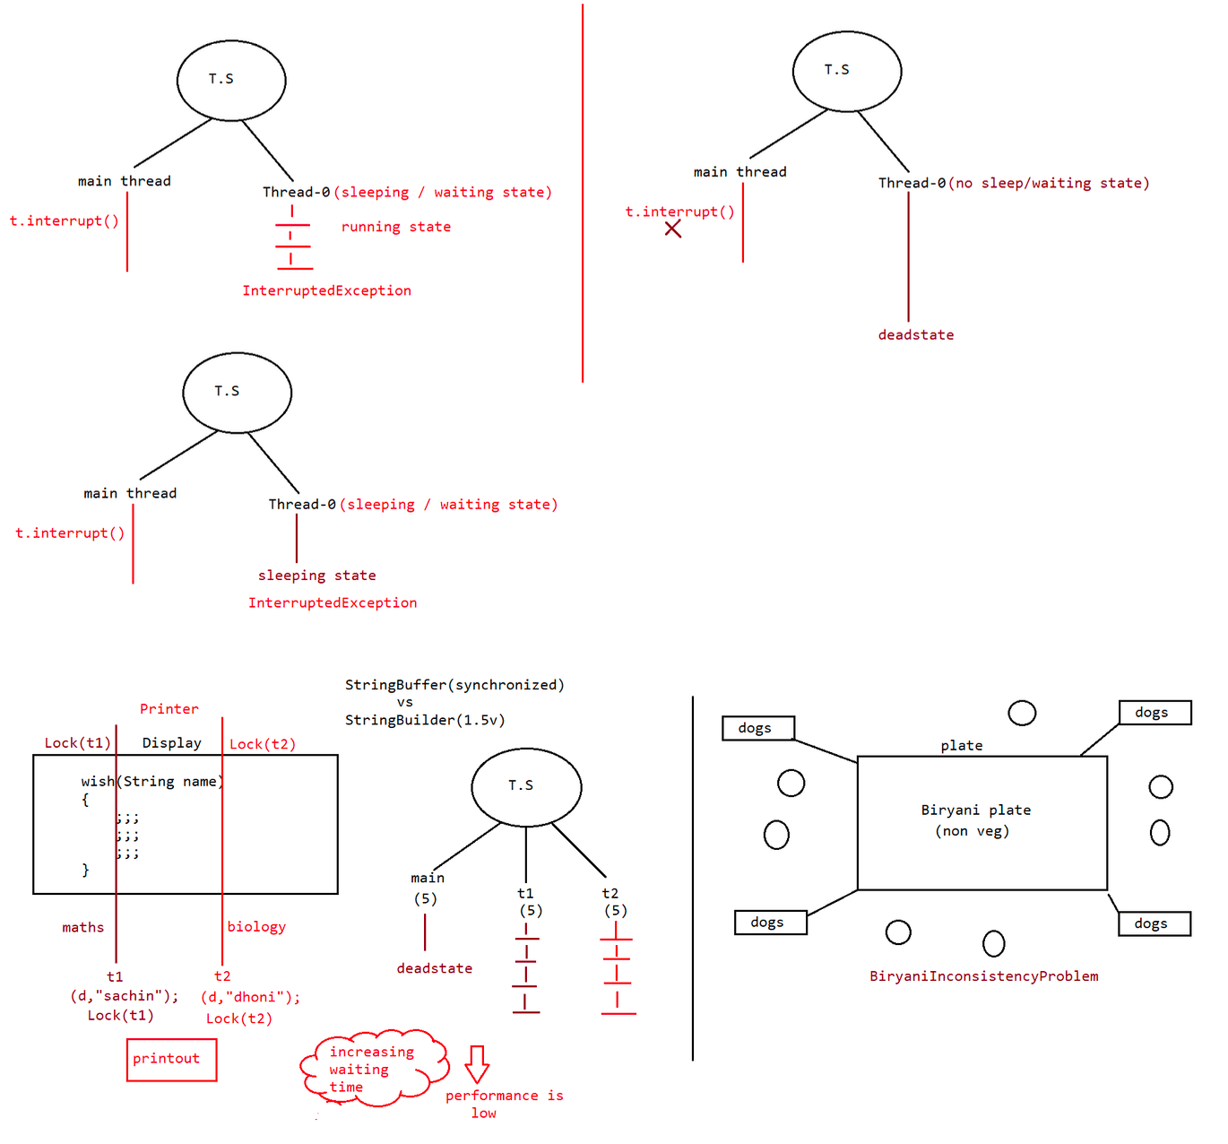
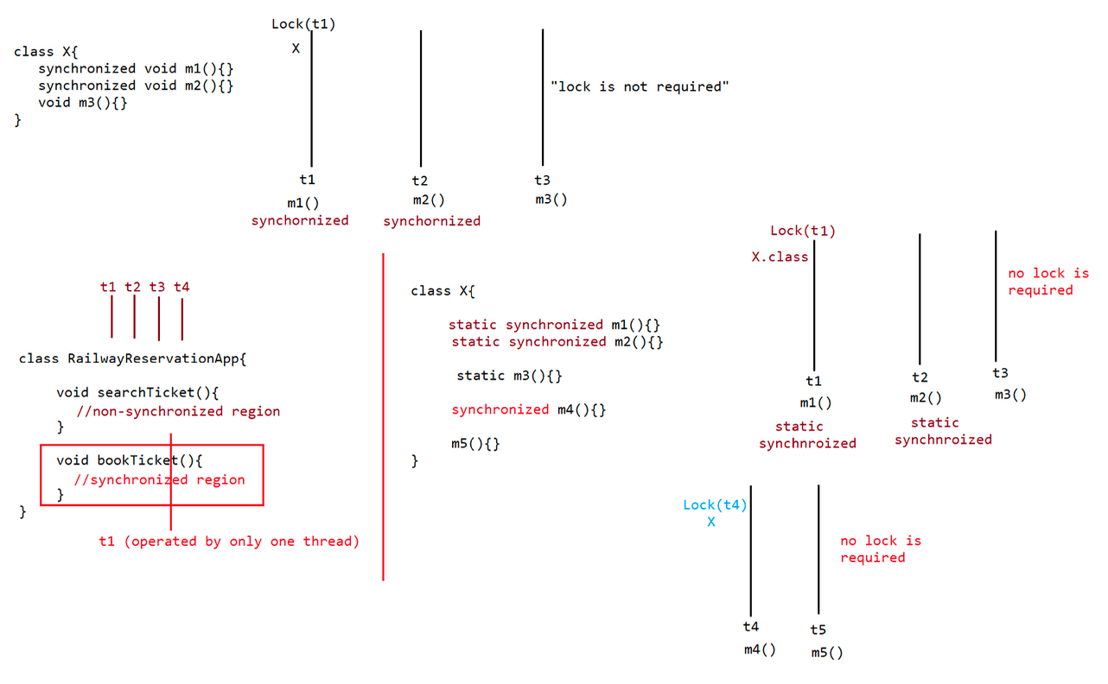
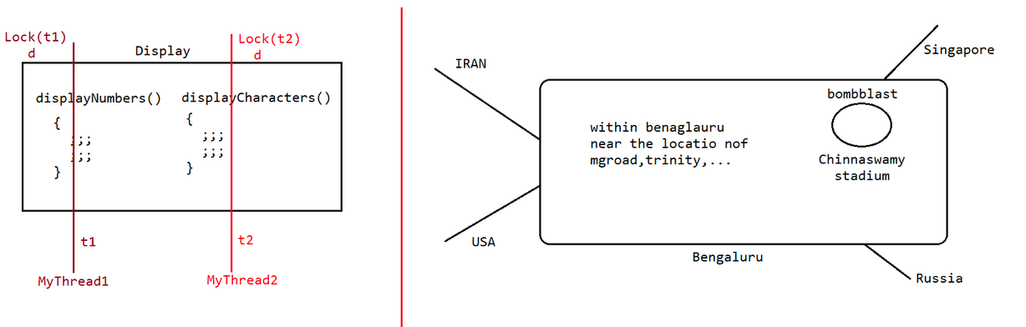

059 Multithreading part 05

synchronized block
===============
eg:1
eg#1.
class Display{
public void wish(String name){
;;;;;;;;;;;;; //l-lakh lines of code
synchronized(this){
for (int i=1;i<=10;i++ )
{
System.out.print("Good morning:");
try{
Thread.sleep(2000);
}
catch (InterruptedException e){}
System.out.println(name);
}
}
;;;;;;;;;;;;;//1-lakh lines of code
}
}
class MyThread extends Thread{
Display d;
String name;
MyThread(Display d,String name){
this.d=d;
this.name=name;
}
}
public void run(){
d.wish(name);
}
class Test {
public static void main(String[] args) {
Display d=new Display();
MyThread t1=new MyThread(d,"dhoni");
MyThread t2=new MyThread(d,"yuvi");
t1.start();
t2.start();
}
}
eg#2.
class Display{
public void wish(String name){
;;;;;;;;;;;;; //l-lakh lines of code
synchronized(this){
for (int i=1;i<=10;i++ )
{
System.out.print("Good morning:");
try{
Thread.sleep(2000);
}catch (InterruptedException e){}
System.out.println(name);
}
}
;;;;;;;;;;;;;//1-lakh lines of code
}
}
class MyThread extends Thread{
Display d;
String name;
MyThread(Display d,String name){
this.d=d;
this.name=name;
}
}
public void run(){
d.wish(name);
}
public class Test {
public static void main(String[] args) {
Display d1=new Display();
Display d2=new Display();
MyThread t1=new MyThread(d1,"dhoni");
MyThread t2=new MyThread(d2,"yuvi");
t1.start();
t2.start();
}
}
Output::Irregular output becoz two object and two threads acting on two different
objects
eg#3.
class Display{
public void wish(String name){
;;;;;;;;;;;;; //l-lakh lines of code
synchronized(Display.class){
for (int i=1;i<=10;i++ )
{
System.out.print("Good morning:");
try{
Thread.sleep(2000);
}
catch (InterruptedException e){}
System.out.println(name);
}
}
;;;;;;;;;;;;;//1-lakh lines of code
}
}
class MyThread extends Thread{
Display d;
String name;
MyThread(Display d,String name){
this.d=d;this.name=name;
}
}
public void run(){
d.wish(name);
}
public class Test {
public static void main(String[] args) {
Display d1=new Display();
Display d2=new Display();
MyThread t1=new MyThread(d1,"dhoni");
MyThread t2=new MyThread(d2,"yuvi");
t1.start();
t2.start();
}
}
Note:: 2 object, 2 thread, but the thread which gets a chance applied class level
lock so output is regular.
Note:: lock concept applicable only for objects and class types, but not for
primitive types. if we try to do it would
result in compile time error saying "unexpected type".
eg:: int x=10;
synchronized(x){//CE: unexpected type found:int required:reference
}
InterThreadCommunication(remember postbox example)
==================================================
Two threads can communicate each other with the help of
a. notify()
b. notifyAll()
c. wait()
notify()=> Thread which is performing updation should call notify(),so the waiting
thread will
get notification so it will continue with its execution with
the updated items.
wait() => Thread which is expecting notification/updation should call wait(),
immediately the
Thread will enter into waiting state.
If a thread wants to call wait(),notify()/notifyall() then compulsorily the thread
should be
the owner of the object otherwise it would result in
"IllegalMonitorStateException".
We say thread to be owner of that object if thread has lock of that object.
It means these methods are part of synchronized block or synchronized method, if we
try to use
outside synchronized area then it would result in RunTimeException called
"IllegalMonitorStateException".
if a thread calls wait() on any object, then first it immediately releases the lock
on that object and it enters into waiting state.
if a thread calls notify() on any object,then he may or may not release the lock on
that object immediately.Except wait(),notify(),notifyAll() lock can't be relased by other methods.
Note::
yield(),sleep(),join() => can't release the lock.
wait(),notify(),notifyAll() => will release the lock,otherwise interthread
communication can't happen.
Once a Thread calls wait(), notify(), notifyAll() methods on any object then it
releases the lock of that particular object but
not all locks it has.
Method prototype of wait(),notify(),notifyAll()
1. public final void wait()throws InterruptedException
2. public final native void wait(long ms)throws InterruptedException
3. public final void wait(long ms,int ns)throws InterruptedException
4. public final native void notify()
5. public final void notifyAll()
Interview Question
================
Method like wait(),notify(),notifyAll() are present inside Object class, y not in
Thread class?
Thread will call wait(),notify(),notifyAll() on Objects like
PostBox,Stack,Customer,Student,....
=> obj.wait(),obj.notify(),obj.notifyAll()
These methods should be available for every object in java,if the method has to
available for every object in java then those
methods should come from "Object" class.
Program
=======
eg#1.
class ThreadB extends Thread{
int total =0;
@Override
public void run(){
for (int i=0;i<=100 ; i++){
total+=i;
}
}
}
public class Test {
public static void main(String[] args)throws InterruptedException {
ThreadB b=new ThreadB();
b.start();
stmt-1;
System.out.println(b.total);
}
}
A. stmt-1
statement
if i replace with Thread.sleep(10000) then thread will enter into waiting
but within 1ns only the updation value is ready.
with in 10 sec if the updation is not ready, then we should not use
Thread.sleep(10000)B. stmt-2
if i replace with b.join(), then main thread will enter into waiting
state,then child will
execute for loop,till then main thread has to wait.
main thread is waiting for updation result.
for (int i=0;i<=100 ; i++){
total+=i;
}
//1cr lines of code is available
main thread has to wait till 1 cr lines of code,y main thread should wait
for the
complete code to finish.
eg#2.
class ThreadB extends Thread{
int total =0;
@Override
public void run(){
synchronized(this){
System.out.println("Child thread started calculation");
for (int i=0;i<=100 ; i++){
total+=i;
}
System.out.println("Child thread trying to give notification");
this.notify();
}
}
}
public class Test {
public static void main(String[] args)throws InterruptedException {
ThreadB b=new ThreadB();
b.start();
Thread.sleep(10000);//10sec
synchronized(b){
System.out.println("Main thread is calling wait on B object");
b.wait();
System.out.println("Main thread got notification");
System.out.println(b.total);
}
}
}
Output
======
Child thread started calculation
Child thread trying to give notification
Main thread is calling wait on B object
becoz of Thread.sleep(10000) main thread will never get notification.
eg#3.
class ThreadB extends Thread{
int total =0;@Override
public void run(){
synchronized(this){
System.out.println("Child thread started calculation");//step-2
for (int i=0;i<=100 ; i++){
total+=i;
}
System.out.println("Child thread trying to give notification");//step-3
this.notify();
}
}
}
public class Test {
public static void main(String[] args)throws InterruptedException {
ThreadB b=new ThreadB();
b.start();
synchronized(b){
System.out.println("Main thread is calling wait on B object");//step-1
b.wait(10000);//10sec
System.out.println("Main thread got notification");//step-4
System.out.println(b.total);
}
}
}
Output
======
Child thread started calculation
Child thread trying to give notification
Main thread is calling wait on B object for 10sec
Main thread got notification
5050
ProducerConsumer Problem
========================
Producer => produce the item and update in the Queue
Consumer => consume the item from the Queue
class Producer extends Thread{
Producer(){
synchronized(q){
produce the item and update it to queue
q.notify();
}
}
}
class Consumer extends Thread{
Consumer(){
synchronized(q){
if(q is empty){
q.wait();
}else{
consume the item from the queue
}
}
}}
Difference b/w notify and notifyAll()
notify() => To give notification only for one waiting thread
notifyAll() => To give notification for many waiting thread
=> We can use notify() method to give notification for only one Thread. If multiple
Threads are waiting then only one Thread will get the chance and remaining
Threads has to wait for further notification.
But which Thread will be notify(inform) we can't expect exactly it depends on
JVM.
eg:: waiting state
|
| obj1.wait(); 60 threads are waiting
obj1.notify() |
|
Running state
Among 60 threads which thread will get a chance we don't have control over that it
is decided
by JVM(threadscheduler).
=> We can use notifyAll() method to give the notification for all waiting Threads
of particular object.
All waiting Threads will be notified and will be executed one by one, because
they required lock.
eg:: waiting state
obj1.notifyAll() | |
| obj1.wait(); 60 threads are waiting
obj2.wait(); 40 threads are waiting
|
Running state
Note: On which object we are calling wait(), notify() and notifyAll() methods that
corresponding object lock we have to get but not other object locks.
eg:: Stack s1=new Stack();
Stack s2=new Stack();
synchronized(s1){
s2.wait();//RE: IllegalMonitorStateException
}
synchronized(s2){
s2.wait();(valid)
}
Question based on lock
======================
1. If a thread calls wait() immediately it will enter into waiting state without
releasing any lock.(false)
2. If a thread calls wait() it releases the lock of that object but may not
immediately (false)
3. If a thread calls wait() on any object,it releases all locks acquired by that
thread and enters into waiting state(false)
4. If a thread calls wait() on any object,it immediately releases the lock of that
particular object and entered into
waiting state(true).
5. If a thread calls notify() on any object,it immediately releases the lock ofthat particular object(invalid)
6. If a thread calls notify() on any object,it releases the lock of that object but
may not immediately(true)

Q>
public interface A111 {
String s = "yo";
public void method1();
}
interface B {
}
interface C extends A111, B {
public void method1();
public void method1(int x);
}
What is the result?
A. Compilation succeeds.
B. Compilation fails due to multiple errors.
C. Compilation fails due to an error only on line 20.
D. Compilation fails due to an error only on line 21.
E. Compilation fails due to an error only on line 22.
F. Compilation fails due to an error only on line 12.
Answer: A
Q>
Given:
public class Yikes {
public static void go(Long n) {
System.out.print("Long ");
}
public static void go(Short n) {
System.out.print("Short ");
}
public static void go(int n) {
System.out.print("int ");
}
public static void main(String[] args) {
short y = 6;
long z = 7;
go(y);//short----> int
go(z);//long ====> Long
}
}
What is the result?
A. int Long
B. Short Long
C. Compilation fails.
D. An exception is thrown at runtime.
Answer: A
Given:
class Alpha {
public void foo() { System.out.print("Afoo "); }
}
public class Beta extends Alpha {
public void foo() { System.out.print("Bfoo "); }//overriden method
public static void main(String[] args) {
Alpha a = new Beta();
Beta b = (Beta)a;
a.foo();b.foo();
}
}
What is the result?
A. Afoo Afoo
B. Afoo Bfoo
C. Bfoo Afoo
D. Bfoo Bfoo
E. Compilation fails.
F. An exception is thrown at runtime.
Answer: D
Q>
Given:
1. public class Target {
2. private int i = 0;
3. public int addOne() {
4. return ++i;
5. }
6. }
And:
1. public class Client {
2. public static void main(String[] args){
3. System.out.println(new Target().addOne());// 1
4. }
5. }
Which change can you make to Target without affecting Client?
A. Line 4 of class Target can be changed to return i++; -> result will be 0
B. Line 2 of class Target can be changed to private int i = 1; -> result will be 2
C. Line 3 of class Target can be changed to private int addOne(){-> we can' t make
a call becoz it is private method
D. Line 2 of class Target can be changed to private Integer i = 0;
Answer: D
Q>
Given:
class Animal {
public String noise() {
return "peep";
}
}
class Dog extends Animal {
public String noise() {
return "bark";
}
}
class Cat extends Animal {
public String noise() {
return "meow";
}
}
...
30. Animal animal = new Dog();
31. Cat cat = (Cat)animal;
32. System.out.println(cat.noise());
What is the result?A. peep
B. bark
C. meow
D. Compilation fails.
E. An exception is thrown at runtime.
Answer: E
Q>
Given:
1. public class Venus {
2. public static void main(String[] args) {
3. int[] x = { 1, 2, 3 };
4. int y[] = { 4, 5, 6 };
5. new Venus().go(x, y);
6. }
7.
8. void go(int[]... z) {
9. for (int[] a : z)
10. System.out.print(a[0]);
11. }
12.}
What is the result?
A. 1
B. 12
C. 14
D. 123
E. Compilation fails.
F. An exception is thrown at runtime.
Answer: C

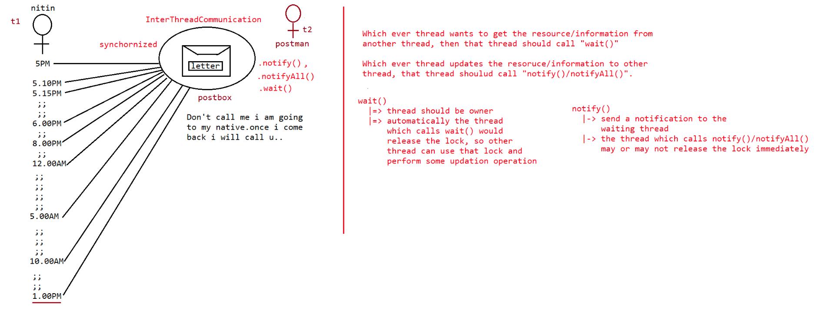
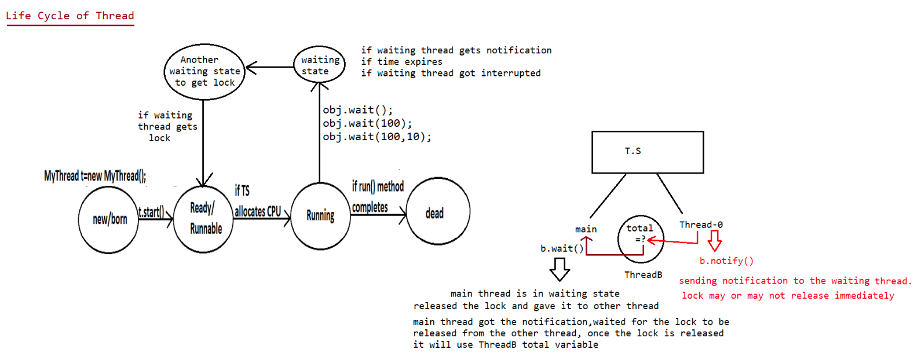
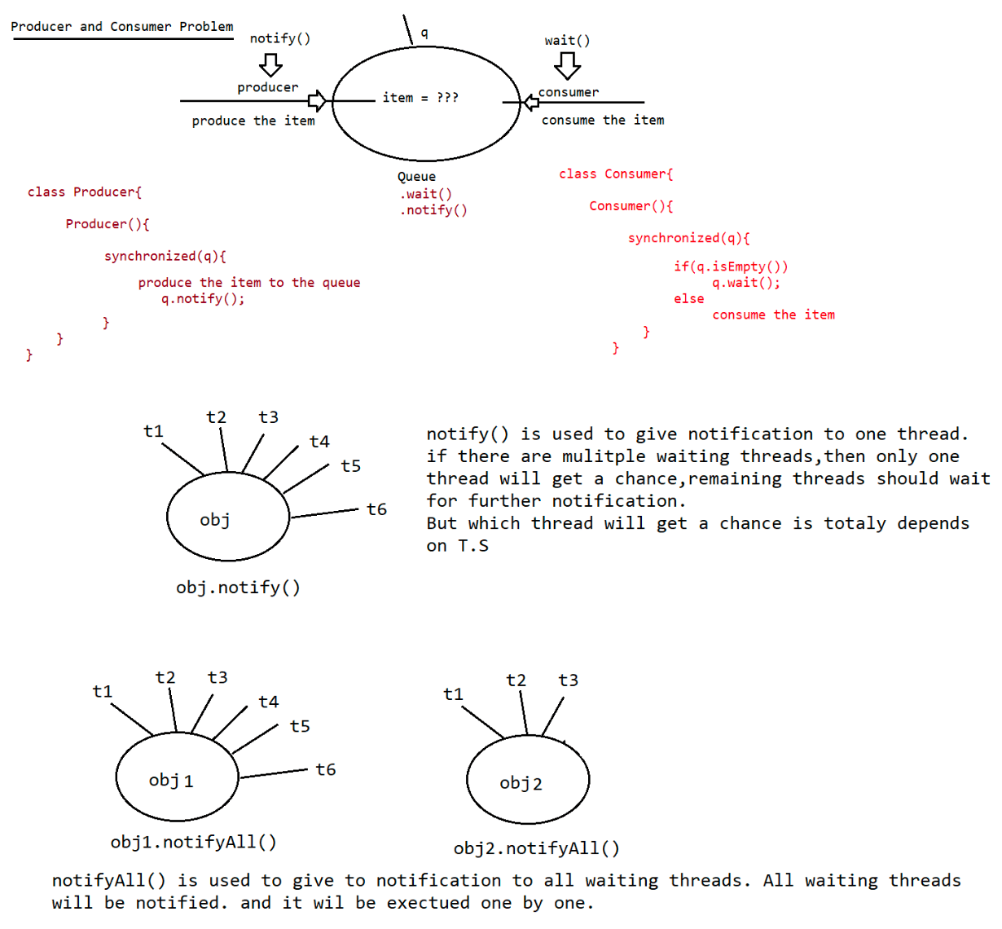

060 Multithreading 06 And Summary revision of core Java
DeadLock
========
If 2 Threads are waiting for each other forever(without end) such type of situation
(infinite waiting) is called dead lock.
There are no resolution techniques for dead lock but several prevention(avoidance)
techniques
are possible.
Synchronized keyword is the cause for deadlock hence whenever we are using
synchronized keyword
we have to take special care.
eg#1.
class A {
public void d1(b b){
try{
System.out.println("Thread-1 starts execution of d1()");
Thread.sleep(5000);//5sec
}
catch (InterruptedException e){
}
System.out.println("Thread-1 trying to call b last()");
b.last();
public void last(){
System.out.println("Inside A last() method");
}
}
}
class B {
public void d2(A a){
try{
System.out.println("Thread-2 starts execution of d2()");
Thread.sleep(5000);//5sec
}
catch (InterruptedException e){
}
System.out.println("Thread-2 trying to call A last()");
a.last();
}
public void last(){
System.out.println("Inside B last() method");
}
}
public class Test extends Thread {
A a=new A();
B b=new B();
public void m1(){
this.start();
a.d1(b);//executed by main thread
}
}
public void run(){
b.d2(a);//executed by child thread
public static void main(String[] args){
Test t=new Test();
t.m1();}
}
since methods are not synchronized,lock is not requried, so no deadlock
Output
Thread-1 starts execution of d1()
Thread-2 starts execution of d2()
Thread-1 trying to call B last()
Inside B last() method
Thread-2 trying to call A last()
Inside A last() method
eg#3.
class A extends Thread{
public synchronized void d1(B b){
System.out.println("Thread-1 starts execution of d1()");
try{
Thread.sleep(5000);//5sec
}
catch (InterruptedException e){
}
System.out.println("Thread-1 trying to call B last()");
b.last();
}
public synchronized void last(){
System.out.println("Inside A last() method");
}
}
class B extends Thread{
public synchronized void d2(A a){
System.out.println("Thread-2 starts execution of d2()");
try{
Thread.sleep(5000);//5sec
}
catch (InterruptedException e){
}
System.out.println("Thread-2 trying to call A last()");
a.last();
}
public synchronized void last(){
System.out.println("Inside B last() method");
}
}
public class Test extends Thread {
A a=new A();
B b=new B();
public void m1(){
this.start();
a.d1(b);//line executed by main thread
}
}
public void run(){
b.d2(a);//line executed by child thread
public static void main(String[] args){Test t=new Test();
t.m1();//main thread s executing
}
}
In the above program, there is a possiblity of "deadlock".
Output
Thread-1 starts execution of d1()
Thread-2 starts execution of d2()
Thread-1 trying to call B last()
Thread-2 trying to call A last()
//here cursor will be waiting
t1 => starts d1(),since d1() is synchronized and a part of 'A' class so t1 applies
lockof(A) and
starts the execution, while executing it encounters Thread.sleep().so T.S
gives chance
for t2 thread.
After getting a chance again by TS, it tries to execute b.last.
but lock of b is with t2 thread, so t1 enters into waiting state.
t2=> starts d2(),since d2() is synchronized and a part of 'B' class so t2 applies
lockof(B) and
starts the execution, while executing it encounter Thread.sleep(),so TS gives
chance again for t1 thread.
After getting a chance again by TS, it tries to execute a.last
but lock of a is with t1 thread, so t2 enters into waiting state.
Since both the threads are in waiting state and it would be waiting for ever,so we
say the above pgm would result in "DeadLock".
Note:
when we use
wont enter into
dead lock.
synchronized is the only reason why there is a deadlock,so we should be careful
synchronized keyword,if we remove atleast one synchronized word then the program
DeadLock vs starvation
======================
Long waiting of a thread, where waiting never ends is termed "deadlock".
Long waiting of a thread, where waiting ends at certain point is called
"starvation".
eg:: Assume we have 1cr threads, where all 1cr threads have priority is 10,but one
thread is there
time but still
"Starvation".
which has priority 1,now the thread with a priority-1 has to wait for long
it gets a chance,but it has to wait for long time, this scenario is called
Note::
certain
Low priority thread has to wait untill completing all priority threads but ends at
point which is nothing but starvation.
Daemon Threads==============
The thread which is executing in the background is called "DaemonThread".
eg: AttachListener,SignalDispatcher,GarbageCollector,....
remember the example of movie
1. producer
2. director
3. music director
4. ....
5. ....
6. ....
MainObjective of DaemonThread
The main objective of DaemonThread, to provide support for Non-Daemon
threads(main thread).
eg:: if main threads runs with low memory then jvm will call GarbageCollector
thread, to destroy
the useless objects,so that no of bytes of free memeory will be improved with
this free
memory main thread can continue its execution.
Usually Daemon threads having low priority,but based on our requirement daemon
threads can run
with high priority also.
JVM => creates 2 threads
a. Daemon Thread(priority=1,priority=10)
b. main (priority=5)
while executing the main code, if there is a shortage of memory
then immediately
jvm will change the priority of Daemon thread to 10, so Garbage
collector
activates Daemon thread and it frees the memory after doing it
immediately
it changes the priority to 1, so main thread it will continue.
How to check whether the Thread is Daemon or not?
public boolean isDaemon() => To check wheter the thread is "Daemon"
public void setDaemon(boolean b) throws IllegalThreadStateException
b=> true,means the thread will become Daemaon,before starting the
Thread we need
to make the thread as "Daemon" otherwise it would result in
"IllegalThreadStateException".
What is the deafult nature of the Thread?
Ans. By deafult the main thread is "NonDaemon".
for all remaining thread Daemon nature is inherited from Parent to child,
that is
if the parent thread is "Daemon" then child thread will become "Daemon" and
if the parent
thread is "NonDaemon" then automatically child thread is also "NonDaemon".
Is it possible to change the NonDameon nature of Main Thread?
Ans. Not possible, becoz the main thread starting is not in our hands, it will be
started by
"JVM".
eg::
class MyThread extends Thread{}
public class Test {public static void main(String[] args){
System.out.println(Thread.currentThread().isDaemon());//false
Thread.currentThread().setDaemon(true);//RE:IllegalThreadStartException
MyThread t=new MyThread();
System.out.println(t.isDaemon());//false
t.setDaemon(true);
t.start();
System.out.println(t.isDaemon());//true
}
}
Note::
Whenever last NonDaemon threads terminates,automatically all Daemon Threads will be
terminated
irrespective of their position.
eg:: makeup man in shooting is a DaemonThread
hero is main thread
if hero role is over, then automatically the makeup role is also over
automatically.
eg::
class MyThread extends Thread{
public void run(){
for (int i=1;i<=10 ;i++ ){
System.out.println("child thread");
try{
Thread.sleep(2000);//2sec
}
catch (InterruptedException e){
System.out.println(e);
}
}
}
}
public class Test {
public static void main(String[] args){
MyThread t=new MyThread();
t.setDaemon(true);//stmt-1
t.start();
System.out.println("end of main thread");
}
}
Output:
with its
execution.
if we comment stmt-1, then both the threads are NonDaemon threads it would continue
end of main thread
child thread
child thread
...
...
...
Output
If we remove comment on stmt-1, then main thread is NonDaemon thread where as
userdefined thread is DaemonThread, if the main thread finishes the execution then
automatically theDaemonThread also will finish the execution.

